Open the TI-Nspire document Slope_and_Tangent.tns.  You have probably thought a lot about the tangent function, especially as the ratio of sine and cosine. But did you know it’s related to algebra you already know? This activity will show you how the tangent of an angle is related to the slope of a line. | 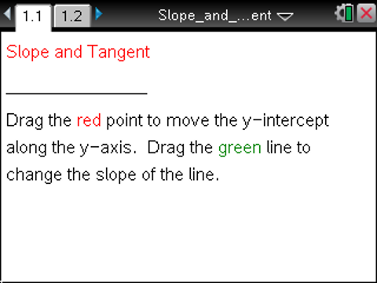

Move to page 1.2. | Press / ¢ and / ¡ to navigate through the lesson.
1. Drag the y-intercept so that the horizontal line goes through the origin. Then drag the slanted line so that the line appears to pass through another grid point.
- How would you find the slope of the slanted line by hand?

- Explain carefully how this process relates to rise over run. Where is the rise? Where is the run?

- Now drag the y-intercept up and down. What happens to the slope of the slanted line as the intercept changes? Why?

2. Drag the slanted line up and down, and observe the changes in the slope.
a. The angle θ is the angle between the slanted line and a line parallel to the x-axis. What happens to the tangent of the angle as the slope changes?

b. Move the slanted line back to its original position at the beginning of question 1. Explain carefully how you would find the tangent of the angle by hand.

c. Why does it make sense that the tangent of the angle between the slanted line and the x-axis is the same as the slope of the line?

3. Move the slanted line so that it decreases from left to right, and the right hand side of the line is below the line parallel to the x-axis.
a. What happens to the relationship between the slope and the tangent of the angle here?

b. How do you explain the difference between the two values?

c. Write a rule relating the slope of a line to the tangent of the angle between the line and the
x-axis, taking into account the possible differences in sign between the slope and the tangent. Explain why your rule makes sense.

4. What if you drew another horizontal line (parallel to the x-axis)? Would the relationship between the slope of the slanted line and the tangent of the angle formed with this horizontal line still hold? Explain.

5. Suppose you did not know the tangent of the angle between the line and the x-axis, but you did know the sine of the angle. Could you determine the slope? Would you need any other information? Explain. You might want to calculate the sine of the angle on the line given for insight.

6. Suppose you were building a ramp, and you knew that the building code required that the ramp be at an angle between 12° and 15°. How could you use this information and the work in the preceding questions to find possible dimensions (i.e. length and height) of your ramp?

7. The angle of elevation is the angle from the horizontal to an object. For example, if you draw an imaginary horizontal line at your eye level, the angle between that line and your line of sight to the top of a tree is the angle of elevation (see the picture below). If your eye level is 66 inches above the ground, and you are standing on level ground looking at a tree in your yard that is 22 feet tall and 12 feet away, what is the angle of elevation from your eye level to the top of the tree? Explain.

θ

