Open the TI-Nspire document Recipe_Unit_Rate.tns.  In this activity, you will explore the relationship between the number of cups of hot water and the corresponding number of scoops of hot chocolate mix for a recipe to make hot chocolate. You will plot points representing this relationship and will search for a pattern that can help you answer questions about the relationship. | 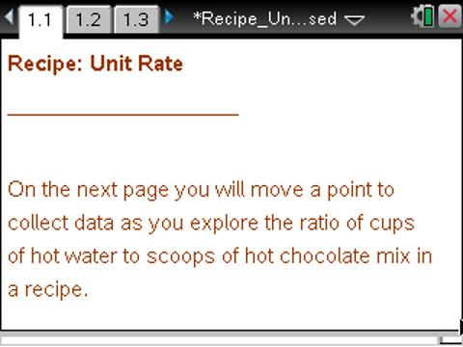

Move to page 1.2.

1. After trying to perfect your recipe for hot chocolate, you find that two cups of hot water dissolves four scoops of the hot chocolate mix. For you, this combination is just right. Now that you have found the right recipe, you envision making larger batches for your friends when they visit you.
a. Look at the graph on this page. Each point on the graph represents a recipe for adding hot chocolate mix to water. What is the meaning of one unit along the horizontal axis?

b. One unit along the vertical axis?

2. What does the ordered pair (2,4) represent? How does this point relate to the recipe for hot chocolate?

3. Use the recipe of two cups of hot water for four scoops of hot chocolate mix to answer these questions.
a. Given one cup of hot water, how many scoops of hot chocolate mix do you use?

b. What ordered pair would you use to represent this point?

c. Move P to these coordinates.

4. Use the recipe to identify three more points. Describe the pattern you followed to plot these points. Record the ordered pairs below.

5. Is it possible to have the point (8, 14) on your graph if you continue with this pattern? Why or why not?

6. What is the total number of scoops of hot chocolate mix you need in each case below? Explain how you found your answer.
a. 12 cups of hot water.

b. 20 cups of hot water.

7. Rates are often measured per single unit. For example, for speed we usually say 30 miles per hour rather than 60 miles per 2 hours. Express the rate in the recipe as the number of scoops of how chocolate mix per one cup of hot water.

Move to page 1.3.

8. Use the slider button to make a line appear.
a. What is the equation of this line?

b. Does this line pass through the points you have marked? Why or why not?

c. This line passes through (0,0). Explain why this makes sense for this recipe.

d. According to our rule, the point (-2, -4) is on the line. Explain why this does or does not make sense for this recipe.

9. Suppose one of your friends likes to put six scoops of hot chocolate mix into two cups of hot water.
a. What is the unit rate for this friend’s recipe?

b. How would the graph for this friend’s recipe compare to the graph for the original recipe?

c. What is the equation of the line for this friend’s recipe? Will the friend’s hot chocolate be stronger or weaker than the original recipe?

