Exercise 1
1. Identify the zeros of y = x² – 4 by graphing the equation. If needed, use the zero command found under  . | 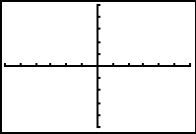
2. You may already know the zero product property, and can demonstrate why the following are the solutions to the equation above:
x + 2 = 0 and x – 2 = 0

3. A program, QUAD, is provided that has the Quadratic Formula defined. Use A = 1, B = 0, and C = –4. What are the solutions to the equation y = x² – 4?

Exercise 2
4. Now, examine the graph of y = x² + x – 6. Graph the equation at the right. Determine the zeros. Write the factored form below.
Use the QUAD program again. You only need to enter in the correct values for a, b, and c. This should confirm your answers for the x-intercepts.
5. What are the solutions to the equation y = x² + x – 6?

Exercise 3
6. Now, examine the graph of y = x² – 4x + 4. Graph the equation at the right. Determine the zeros. Write the factored form below.
7. Using the QUAD program, what are the solutions to the equation y = x² – 4x + 4?

Exercise 4
8. Explore y = x² – 2x – 7, which is not factorable with integers. You may ask why this quadratic function is not factorable and the previous examples were. Make a conjecture about why you think this could be true:
- “Some quadratic equations are not factorable with integers because…”

or
- “Quadratic equations are only factorable with integers when…”

9. Solve the following equations using the QUAD program.
- y = x² – 2x – 7

- y = –3x² + x +3

10. Finally, use Lists to calculate the value of the discriminant for the previous two problems, whose solutions were irrational. Enter the A coefficient in L1, B in L2, and C in L3. Then, in L4, move to heading and enter the formula for the discriminant shown at the right. | 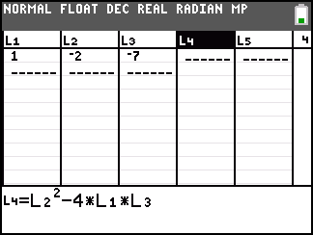
- y = x² – 2x – 7 discriminant: _____________________________________

- y = –3x + x +3 discriminant: ____________________________________

Extensions/Homework
Use the formula in L4 (above) to calculate the Discriminant for several other quadratics. Decide if the equation is factorable using integers, then solve it. Factor the quadratic if possible, if not, solve by the quadratic formula. If the quadratic has no real zeros, write “no real zeros.”
1. y = x² – 6x + 9

2. y = 3x² + 4x + 5

3. y = –4x² + 2x + 2

4. y = 7x² + x – 8

5. y = 2x² – 5

Look at the flow chart below and discuss with another student how to use it to answer these homework problems.
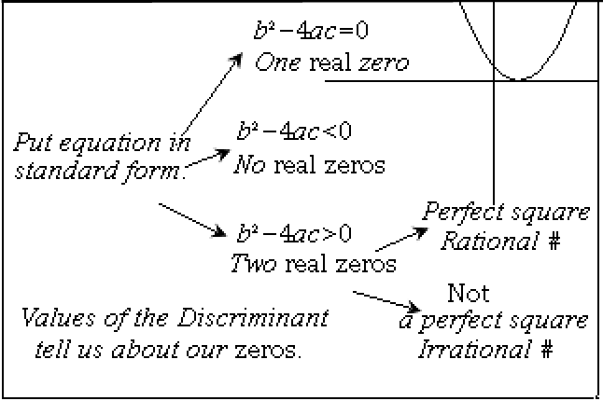
6. Sketch a different graph for each of the four scenarios, though one is already pictured.

