Open the TI-Nspire document Heat_of_Fusion.tns.  In this experiment, you will determine the energy (in Joules) required to melt one gram of ice. We will also explore the molar heat of fusion for ice (in kJ/mol). | 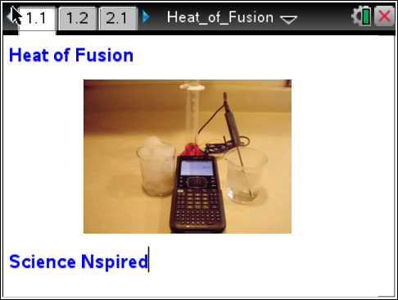

Melting and freezing behavior are among the characteristic properties that give a pure substance its unique identity. As energy is added, pure solid water (ice) at 0°C changes to liquid water at 0°C

In this experiment, excess ice will be added to warm water, at a known temperature, in a Styrofoam cup. The warm water will be cooled down to a temperature near 0°C by the ice. The energy required to melt the ice is removed from the warm water as it cools.

To calculate the heat that flows from the water, you can use the relationship:
Q = m•s•Δt
where Q stands for heat flow, s is specific heat capacity, m is mass in grams, and Δt is the change in temperature. For water, s is 4.18 J/g°C.

Move to page 1.2.

Answer the following question on the handheld.
Q1. What actually happens when ice melts in a glass of room temperature soda?
A. The warmth from soda melts the ice
B. The heat from the soda is transferred to the ice.
C. The cold from the ice is transferred to the soda.
D. The cold from the ice cools the soda.

Move to page 2.1.

1. Connect the Temperature Probe to a TI-Nspire™ handheld.
- An EasyTemp™ can be connected directly to the handheld using the mini-USB port, or a Stainless Steel Temperature Probe can be connected using and EasyLink™ or TI-Lab Cradle™.
2. Use a burette clamp to clamp the Temperature Probe on a ring stand as shown to the right.
3. Place a Styrofoam cup into a 600-mL beaker as shown to the right.
4. Use a 100 mL graduated cylinder from your teacher to measure 100.0 mL of water with a temperature of about 60°C.
5. Obtain 7 or 8 large ice cubes.
6. Move to the DataQuest page on the handheld, and select MENU > Experiment > Collection Setup.
7. Change the data-collection rate to 1 sample/second and the data-collection length to 480 seconds. Click OK. Data collection will last 8 minutes.
8. Lower the Temperature Probe into the warm water (to about 1 cm from the bottom).
9. Start data collection by pressing the button.
- The temperature reading, in °C, is displayed to the right of the graph.
10. Wait until the temperature reaches a maximum (it will take a few seconds for the cold probe to reach the temperature of the warm water).
- This maximum will determine the initial temperature, t₁, of the water.
11. As soon as this maximum temperature is reached, fill the Styrofoam cup with ice cubes.
- Shake excess water from the ice cubes before adding them (or dry with a paper towel).
12. Record the maximum temperature, t₁, in the data table at the end of this worksheet.
13. Use a stirring rod to stir the mixture as the temperature approaches 0°C.
Important: As the ice melts, add more large ice cubes to keep the mixture full of ice!
14. When the temperature reaches about 4°C, quickly remove the unmelted ice (using tongs).
15. Shake any remaining water clinging to the ice cubes back into the Styrofoam cup.
16. Continue stirring the water until the temperature reaches a minimum (and begins to rise).
- This minimum temperature is the final temperature, t₂, of the water.
17. Record t₂ in the data table at the end of the worksheet.
Data collection will stop after 8 minutes (or you can press STOP before 8 minutes has elapsed).
18. Use the 100 mL graduated cylinder to measure the volume of water remaining in the Styrofoam cup to the nearest 0.1 mL, and record this as V₂.
29. To confirm the t₁ and t₂ values you recorded earlier, examine the data points along the curve on the displayed graph by tapping any data point.
20. Determine the maximum temperature, t₁, and the minimum temperature, t₂ (rounded to the nearest 0.1°C), and record them in the data table.

Data Table:
Initial volume: ___________mL Mass of water: _________ g Final Volume:_____________mL Mass of ice: _____________ g
Initial temp: ________ºC Lowest temp: _________ ºC
Use the Calculator page following the DataQuest App on the handheld for calculations.
21. Use the equation Δt = t₁ – t₂ to determine Δt, the change in water temperature.
22. Subtract final volume of the water from the initial volume of water to determine the volume of ice that was melted (V₂ –V₁).
23. Find the mass of ice melted using the volume of melt (use 1.00 g/mL as the density of water). Record in Calculations Data Table below.
24. Use the equation Q = m•s•Δt to calculate the energy (in joules) released by the 100 g of liquid water as it cooled through Δt .

25. Now use the results obtained above to determine the heat of fusion, the energy required to melt one gram of ice (in J/g H₂O).

26. Use your answer to Step 26 and the molar mass of water to calculate the molar heat of fusion for ice (in kJ/mol H₂O).

27. Find the percent error for the molar heat of fusion value in Step 27. The accepted value for molar heat of fusion is 6.01 kJ/mol.

Calculations Table:
Mass of ice melted ___________g
Heat released by cooling water ___________J
Heat of Fusion of ice melted in ___________J/g
Molar Heat of Fusion of ice ___________kJ/mol
% Error ___________%
Q2. Using your previous knowledge of the boiling point of water and melting point of ice, explain your results in the space below.

Q3. Explain your percent error value. Give possible sources of error.

