Open the TI-Nspire document Assessing_Normality.tns.  In this activity, you will learn the four characteristics of a normal curve. Then you will use the criteria to determine if a given data set is ‘normal’. | 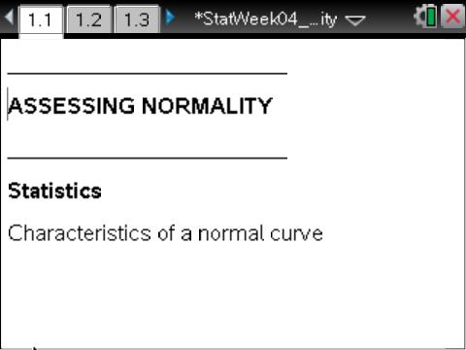

Move to pages 1.2-1.4. | Press / ¢ and / ¡ to navigate through the lesson.
On page 1.2, read the description of the criteria for a normal distribution of data. On page 1.3, you learn about the data you will be assessing. Page 1.4 shows you the data in a spreadsheet.

Move to pages 1.5-1.7.

Let’s investigate two-point shooting percentages to assess their ‘normality’.
1. On page 1.6, construct a histogram to test the first criteria.
- Click the bottom on the screen, and select twopoint.
- Select MENU > Plot Type > Histogram.
- Answer the following questions on page 1.7.
a. What is the overall shape of the histogram?

b. Has the first criteria for a normal distribution been satisfied?

Move to pages 1.8 and 1.9.

2. Use one-variable statistics to calculate the mean and median on page 1.8. Answer the following questions on page 1.9.
a. Are the mean and median approximately equal?

b. By what percent do they differ?

Move to pages 1.10-1.12.

3. Read the criteria on page 1.10, and create a new histogram on page 1.11.
- Use histogram properties to set the mean as the center (alignment) and one standard deviation as the width of each bin (bin width).
4. Hover your curser over each bin of the histogram to see how many values it contains, and calculate the percentage of data points that fall within one, two, and three standard deviations of the mean.
- Use the scratchpad for your calculations.
- Answer the following questions on page 1.12.
a. What is the number of data points in each bin of the histogram?

b. What is the percentage of values within one, two, and three standard deviations?

c. Does the histogram follow the 68-95.5-99.7rule? Explain.

Move to pages 1.13-1.15.

5. Read the criteria on page 1.13, and create the normal probability plot.
- Add the variable twopoint at the bottom of the screen.
- Select MENU > Plot Type > Normal Probability Plot.

A normal curve creates a straight line. The more the data deviates from a straight line, the less normally the data are distributed. Answer the following questions on pages 1.14 and 1.15.
6. What shape does the plot form? What does this tell you?

If your data set passes all four tests, then it is approximately normal and can be modeled with a normal curve. In addition, z-scores can be calculated, and comparisons can be made.
7. Does the data set seem to be normal? Justify your answer.

Extension

Repeat this activity with the data sets threepoint and games.
1. Is the data set threepoint approximately normal? Justify your conclusion.
2. Is the data set games approximately normal? Justify your conclusion.

