Problem 1 – Graphing systems of linear equations
Do all linear systems have just one solution? In this problem, you will graph several different linear systems to see how many solutions they have.
- Graph each system below by solving the equations for y and entering them into Y1 and Y2.  - View the graph in a standard viewing window. (If necessary, set the viewing window by going to Zoom > ZStandard.)  - Sketch each graph. How many solutions does each system have? |  |  | 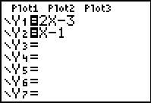
1. $\left\{\begin{matrix}y=2x−3 \\ y=x−1\end{matrix}\right.$ | 2. $\left\{\begin{matrix}y\text{=-}3x+3 \\ y\text{=-}3x−1\end{matrix}\right.$ | 3. $\left\{\begin{matrix}4x+2y=6 \\ y\text{=-}2x+3\end{matrix}\right.$
Sketch:  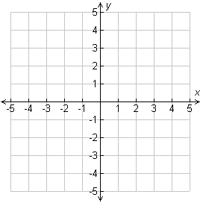 | Sketch: | Sketch:
Number of solutions: | Number of solutions: | Number of solutions:

The three graphs you sketched above show all the possible ways two lines can relate to each other. Fill in the answers for the right column.
If the two lines…  - Cross at a single point  - Never cross (are parallel)  - Are really the same line | Then the system has…  - ___________________  - ___________________  - ___________________

Problem 2 – Create your own system
Can you create a system with one solution? Open the CabriJr file HOWMANY1. It shows the graph of a linear equation.  Use the Line tool to draw a second line on the graph so that the two lines form a linear system with exactly one solution. | 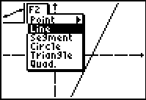
Use the Coordinates and Equations tool to find the equations of the two lines. Record them in the table.  Delete the line you drew. Draw a new line to make a system with no solution. Record the equation of the line in the table. | 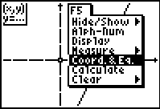
Next, delete that line. Draw a new line to make a system with infinitely many solutions. Record the equation of the line.
Repeat this experiment with the lines you find in the CabriJr files HOWMANY2, HOWMANY3, and HOWMANY4. For each file, make a system with one solution, a system with no solutions, and a system with infinitely many solutions. Record all the equations in the table.

Original Line | One Solution | No Solutions | Infinitely Many Solutions
HOWMANY1  y = | $$\left\{\begin{matrix}y= \\ y=\end{matrix}\right.$$ | $$\left\{\begin{matrix}y= \\ y=\end{matrix}\right.$$ | $$\left\{\begin{matrix}y= \\ y=\end{matrix}\right.$$
HOWMANY2  y = | $$\left\{\begin{matrix}y= \\ y=\end{matrix}\right.$$ | $$\left\{\begin{matrix}y= \\ y=\end{matrix}\right.$$ | $$\left\{\begin{matrix}y= \\ y=\end{matrix}\right.$$
HOWMANY3  y = | $$\left\{\begin{matrix}y= \\ y=\end{matrix}\right.$$ | $$\left\{\begin{matrix}y= \\ y=\end{matrix}\right.$$ | $$\left\{\begin{matrix}y= \\ y=\end{matrix}\right.$$
HOWMANY4  y = | $$\left\{\begin{matrix}y= \\ y=\end{matrix}\right.$$ | $$\left\{\begin{matrix}y= \\ y=\end{matrix}\right.$$ | $$\left\{\begin{matrix}y= \\ y=\end{matrix}\right.$$

Compare the equations for the lines you drew with the equations of the original line that was drawn for you.
4. Which equations have the same slope as the original equation? Those that form a system with one solution, no solution, or many solutions?

5. Which equations have the same y-intercept as the original equation? Those that form a system with one solution, no solution, or many solutions?

6. Which equations are equivalent to the original equation?

7. Why is it sometimes hard to see that two equations in a linear system are equivalent? Give an example.

8. Complete each statement to create some rules about the number of solutions for a linear system of equations.
- A linear system has no solution if the equations have ______ slopes and ______
y-intercepts.
- A linear system has infinitely many solutions if the equations have ______ slopes
and ______ y-intercepts.
- A linear system has one solution if the equations have ______ slopes and ______
y-intercepts.
Determine how many solutions each system has without graphing.
9. $\left\{\begin{matrix}y=x \\ y=2x\end{matrix}\right.$ | 10. $\left\{\begin{matrix}y=\frac{1}{2}x+2 \\ −2y\text{=-}x−4\end{matrix}\right.$ | 11. $\left\{\begin{matrix}3x+4y=\text{12} \\ 2x+4y=8\end{matrix}\right.$ | 12. $\left\{\begin{matrix}y=\frac{1}{2}x+1 \\ y=\frac{1}{2}x+8\end{matrix}\right.$

