Introduction
How fast does a human fetus grow? The data below are the average masses, at various stages of development, of a human fetus.
Weeks of development | Fetal mass in grams
12 | 28
16 | 88
20 | 256
24 | 510
28 | 907
36 | 2,665
40 | 3,204

Objectives
In this activity, you will:
• graph data of human fetal growth
• describe the rate of human fetal growth

You’ll Need
- TI-84 Plus CE, with SCI TOOLS App
Entering the Data
- Turn on your calculator. Press …, Í to go to the List Editor.
- Clear any data from the List Editor by using the arrow keys to move the cursor to the top of each column and pressing ‘, Í
- Enter the data for weeks of development, from the first column in the table, into list L1. To do this, move the cursor to the first row of the column (this will be indicated at the bottom of the screen by “L1(1)=”). Then enter the number 12. Press Í to move the cursor to the next row, and enter the number 16. Continue this process for the rest of the numbers in the column.  - Use the same process to enter the data for fetal mass, from the second column in the table, into L2. | 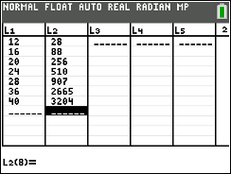
- Now, you will graph your data.
Press Œ and scroll to SCI TOOLS. Press e, and 3 to get to the Data/Graphs wizard.
Press @ to select PLOT DATA
Press @ to select LINE GRAPH.

- Highlight L1 and press e. This identifies your independent variable as weeks of development, which will appear on the x-axis.  - Highlight L2 and press e. This sets fetal mass as your dependent variable, which will appear on the y-axis. | 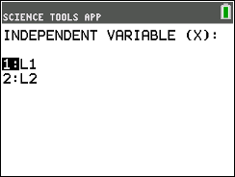  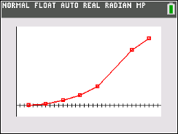
Data Analysis
- Describe fetal growth, in terms of mass and time, as it is shown on your graph.

- Is the mass increase linear or exponential? How do you know?

- According to the graph, what would be the mass of a baby born at 38 weeks? At 26 weeks?

- If the mass of a woman is 64 kg and she delivers a baby of average mass at 40 weeks of gestation, what percentage of the mother’s mass is the baby’s?

