Introduction
Recursive Sequence
A sequence in which each new term is defined in relation to previous terms.
The formula has two parts; (1) the initial condition, and (2) the recursive equation.
Example
a₁ = 3 (initial condition)
a_{n} = a_{n-1} + 2 (recursive equation)

- Write a verbal description of the sequence in the example above.

- Show how you would find the 2nd and 3rd terms of this sequence by hand.

Problem 1 – Generating a recursive sequence
To explore sequences, the calculator needs to be set to sequence mode by pressing the M key and selecting SEQ. | 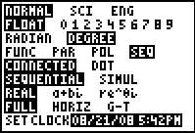
To generate the sequence in the example above, press ! and match the screen to the right.  Note: enter n by pressing x and enter u by pressing `7.  To view this sequence, press `%.  - What are the first 10 terms? | 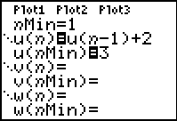

Now it’s your turn. Have your graphing calculator generate a sequence with an initial value of 3 so that the next term is one less than the previous term.
Formula | First 10 Terms

Generate a sequence with an initial value of –3 so that the next term is five more than the twice the previous term.
Formula | First 10 Terms

Problem 2 – Writing a Recursive Equation
Below are two sequences. Write a recursive formula for each sequence. Use your graphing calculator to check if your formulas are correct.
Sequence 1 | Sequence 2
–2, –3.5, –5, –6.5, –8, –9.5 | 0, 3, –6, 21, –60, 183
Formula | Formula

- Explain how you determined the recursive formulas.

