Discovering Exponent Rules
Run the EXPRULES program by pressing  then choosing it from the menu and pressing .  This program allows you to explore 6 different rules of exponents by helping you evaluate exponential expressions for different values of x and y. To begin, choose Experiment, then type 1 to explore Rule 1. | 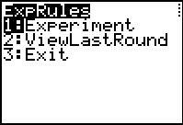
The program displays the expression that you will be calculating to explore Rule 1, 2^{x}2^{y}. Calculate the expression several times, choosing values from 1 through 8 for x and y. Make and test a conjecture.  Repeat this process to explore rules 2 – 6. Pay attention to the prompts, as some rules require you to enter negative values for the variables. Record your conjectures below. | 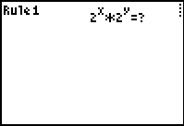
- Rule 1: Make a rule for the product of two powers with like bases.
- Rule 2: Make a rule for the quotient of two powers with like bases.
- Rule 3: Make a rule for the power of a power.
- Rule 4: Make a rule for a power with a negative exponent.
- Rule 5: Make a rule for a power with a zero exponent.
- Rule 6: Make a rule for the power of a quotient.

Extension
Use your calculator to evaluate each of the expressions shown.
Then make a conjecture for .
${\text{36}}^{\frac{1}{2}}$ = ___ | $8^{\frac{1}{3}}$ = ___ | ${\text{49}}^{\frac{1}{2}}$ = ___ | ${\text{16}}^{\frac{1}{2}}$ = ___ | ${\text{16}}^{\frac{1}{4}}$ = ___
Complete:

