Open the TI-Nspire document Functions_and_Inverses.tns.  In this lesson, you will explore functions and their inverses. You will also determine the equation of a function’s inverse. | 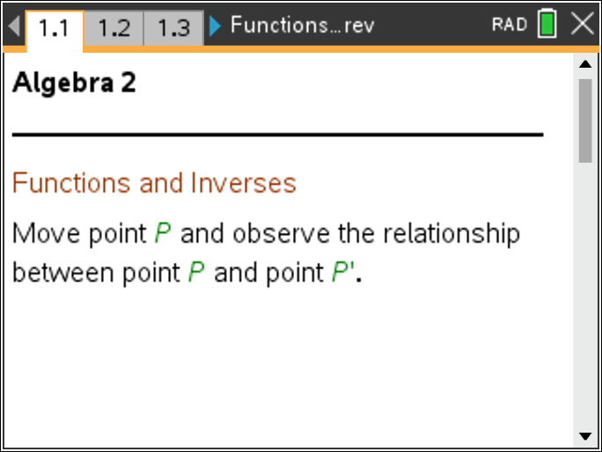

Move to page 1.2. | Press / ¢ and / ¡ to navigate through the lesson.
1. Grab and drag point P.
a. What changes and what remains the same?

b. Record the ordered pairs for point P and point P′ in the tables below.

Point P |  |  | Point P′
x | y |  | x | y

c. Compare the ordered pairs for point P and point P′. How are they alike or different?

Move to page 1.3.

2. Grab and drag point P.
a. What changes and what remains the same?

b. Record some of the ordered pairs for point P and point P′ in the tables below.

Point P |  |  | Point P′
x | y |  | x | y
c. Compare the ordered pairs for point P and point P′. How are they alike or different?

d. Write the equation that represents each set of ordered pairs. Show your work. How are the equations alike or different?

These equations are called inverses. An inverse is the set of ordered pairs obtained by interchanging the x and y elements of each pair in the original function.
Notation: If f is a given function, then f ^{–1} denotes the inverse of f.

Some inverses are functions. They are derived from one-to-one functions. A function is a one-to-one function if and only if each y element corresponds to one and only one x element. A horizontal line test can be used to determine if a function is one-to-one. Not all inverses are functions.

3. Click the ∇ or ∇ on the slider to change the equation.
a. Is the new graph a function? How do you know?

b. Is the graph on the right an inverse of the first? Explain how you know.

c. Write the equations of both graphs. How are the equations alike or different?

d. How could you find the inverse of any function algebraically?

Move to page 1.4.

4. Grab and drag point P.
a. What changes and what remains the same?

b. Record some of the ordered pairs for point P and point P′ in the tables below.

Point P |  |  | Point P′
x | y |  | x | y
c. Compare the ordered pairs for point P and point P′. How are they alike or different?

d. Is the graph of the inverse a function? Why or why not?

e. The equation for the graph that includes point P is y = 0.8(x + 0.5)² – 5. Write the equation for the graph containing point P′.

5. Find the inverse of each equation algebraically.
a.

b.

c.

6 a. Is y = 2^{x} + 2 the inverse of y = x² – 2? Why or why not?

b. Is the inverse of ? Why or why not?

