Introduction
Besides food, what else do you get from plants? Can you think of some other things that may not be spelled out in this chemical equation for photosynthesis that help the plant make food? What makes a plant green and what is the job of that green stuff? What is the fuel, or energy source, for photosynthesis? The more fuel, the more photosynthesis the plant can do, as long as there are enough food-making molecules available. Looking at the equation below, remind yourself what these food-making molecules are. Study the chemical reaction, and answer the questions that follow.

6CO2 + 6H2O → C6H12O6 + 6O2

- Name as many substances in this equation as you can.

- What does the 6 (the coefficient) in front most of the substances mean? Why are coefficients used in a chemical equation?

- Why isn’t there a coefficient in front of C6H12O6?

- What is the name of the reaction that is represented by this equation?

Hopefully, you recognized the equation as the one for photosynthesis, the food-making process in plants. You are completely dependent on plants for food, whether you eat plants, or eat the animals that eat the plants. You are a part of a marvelously woven system called a food web, and plants probably form the foundation of your food web.

Objectives
In this activity, you will:
- examine data about carbon dioxide levels and graph the data.
- make predictions about carbon dioxide in other circumstances, and sketch graphs based on your predictions.

You’ll Need
- TI-84 Plus CE

Carbon Dioxide in Forest by Month
10 20 30 40 50 60 70 80 90 100

1 2 3 4 5 6 7 8 9 10 11 12
Carbon Dioxide
(Relative amounts)

Months (January – December)

Entering the Data
Graph the data from the graph above on you TI-84 Plus CE, and then answer questions about the graph. Using your knowledge of carbon dioxide and photosynthesis, you will then sketch graphs based upon different environmental circumstances.
- Press …. Press Í to choose 1:Edit.
- Clear L1 of all data. Press } to move to the heading L1. Press ‘ Í.
- Repeat this procedure to clear L2 of all data.
- Navigate back to L1, making sure that your cursor is in the first row of the list, and not at the very top. In L1, enter a numerical value for the months from the graph. To do this, type in the number and then press Í, or press †. Repeat this until you have entered all of the months in L1.
- In L2, enter the carbon dioxide values from the graph, making sure that they correspond with the correct month. Be sure you have the same number of data entries in L1 as you do in L2.
- Make a graph of the data.  - Press y, ,.  - Press Í to select 1:Plot1. Set your handheld as shown at the right. | 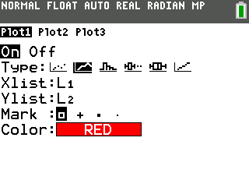
- Press y . and make sure the defaults are set as shown at the right. If you need to change a setting, press † to move the cursor, and then press Í to highlight the item on the left. | 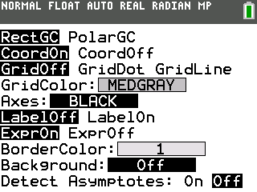
- Press z and make sure the defaults are set as shown at the right. | 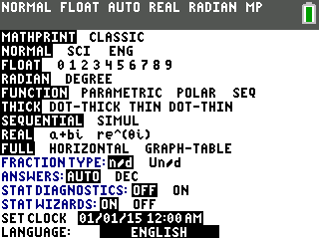
- Press p and set an appropriate window for the data you have entered and wish to graph. A suggested window setting is shown at the right. | 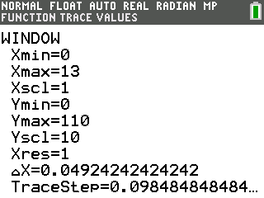
- Press o. If there are any equations on this screen, press † to place the cursor next to Y1=, and then press ‘‚ to clear the equation. Repeat this sequence to clear all equations.
- Press s.

Data Analysis

1. What is the independent variable in this graphical model?

2. What is the dependent variable?

3. Describe what happens to the carbon dioxide concentration in the forest throughout the year, and explain why there is such a variation in CO₂ amounts at different times of the year.

4. According to the graph, when were the trees using CO₂ at the fastest rate? Explain how you decided on your answer.

5. According to the graph, when did the trees lose their leaves? Explain.

6. Explain the increase in CO₂ levels in the forest from June to August.

7. The graph you have been looking at has been a long term graph; one profiling an entire year. With a sketched graph, predict what the CO₂ concentration would look like over the course of a single day in July, starting at 12:00 midnight and ending at 12:00 midnight the following night. Don’t forget to label your axes! Then sketch a predicted graph of what the CO₂ concentration would look like over the course of a single day in January. Below each graph, explain why you decided to draw your graphs the way you did.

CO₂ Concentration for a Single July Day

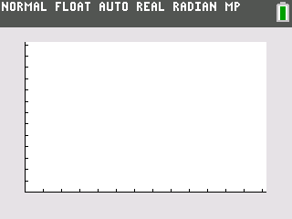

Explanation of your graph:

CO₂ Concentration for a Single January Day

Explanation of your graph:
Predict with a graph what the CO₂ concentration would look like in a tropical rain forest in a day in January. Explain your graph.
Graph Title: __________________________________

Explanation:

8. Go back to the original graph on page 1. Remember that you were observing the carbon dioxide levels in the forest. Make some predictions about the oxygen levels in the forest. Using your graphing calculator, produce a graph that will graphically display your predictions. Sketch your graph below.

Graph Title: __________________________________

