Open the TI-Nspire document Systems_of_Linear_Inequalities_2.tns.  This activity involves finding a system of linear inequalities by mapping a region on a graph. Points will show as the following: not in the region, on the boundary but not in the region, or in the region. The system of inequalities will be confirmed by graphing. | 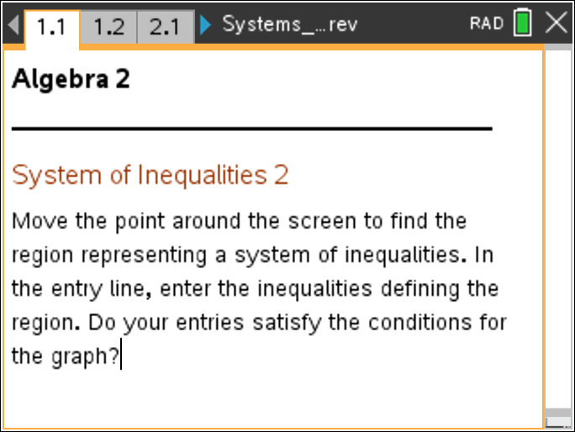

Move to page 1.2. | Press / ¢ and / ¡ to navigate through the lesson.
1. Grab the point and move around the screen to determine the region representing a system of inequalities. Points will be marked in three ways. An “x” represents a point not in the region. An “o” represents a point on the boundary but not in the region. A “●” represents a point in the region.
a. When you have finished identifying the points in the region, make a conjecture as to the system of inequalities. In the entry line, enter the two inequalities that will define the region. If your conjecture is correct, the intersecting region should correspond with the classifications of the points. | Press / G to bring up the entry line. Enter the inequality in the entry line by putting < or > in place of the = for a dotted boundary line. Use <= or >= for a solid boundary line.
b. Explain how you know whether or not the boundary line is included in your answer.

c. Explain how you know in which direction the inequality sign goes.

d. Write the system of inequalities represented on the graph.

Move to page 2.2.
2. Grab the point and move around the screen to determine the region representing a system of inequalities. Points will be marked in three ways. An “x” represents a point not in the region. An “o” represents a point on the boundary line but not in the region. A “●” represents a point in the region.

a. When you have finished identifying the points in the region, make a conjecture as to the system of inequalities. In the entry line, enter the two inequalities that will define the region. If your conjecture is correct, the intersecting region should correspond with the classifications of the points. | Press / G to bring up the entry line. Enter the inequality in the entry line by putting < or > in place of the = for a dotted boundary line. Use <= or >= for a solid boundary line.
b. Write the system of inequalities represented on the graph.

Move to page 3.2.
3. Grab the point and move around the screen to determine the region representing a system of inequalities. Points will be marked in three ways. An “x” represents a point not in the region. An “o” represents a point on the boundary line but not in the region. A “●” represents a point in the region.
a. When you have finished identifying the points in the region, make a conjecture as to the system of inequalities. In the entry line, enter the two inequalities that will define the region. If your conjecture is correct, the intersecting region should correspond with the classifications of the points. | Press / G to bring up the entry line. Enter the inequality in the entry line by putting < or > in place of the = for a dotted boundary line. Use <= or >= for a solid boundary line.
b. Write the system of inequalities represented on the graph.

Move to page 4.2.
4. Grab the point and move around the screen to determine the region representing a system of inequalities. Points will be marked in three ways. An “x” represents a point not in the region. An “o” represents a point on the boundary line but not in the region. A “●” represents a point in the region.
a. When you have finished identifying the points in the region, make a conjecture as to the system of inequalities. In the entry line, enter the two inequalities that will define the region. If your conjecture is correct, the intersecting region should correspond with the classifications of the points. | Press / G to bring up the entry line. Enter the inequality in the entry line by putting < or > in place of the = for a dotted boundary line. Use <= or >= for a solid boundary line.
b. Write the system of inequalities represented on the graph.

