Problem 1
Before beginning this activity, change your window settings to match those to the right.  Enter the function f(x) = b^{x} with 5 different values of b (for b > 0). Choose some values that are greater than 1 and some values that are less than one. Then, press graph to graph the functions. | 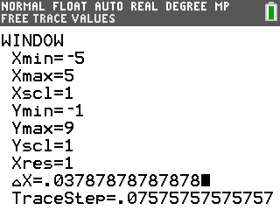
Use trace to observe how the value of b affects the shape of the graph. Use the up and down arrows to move among the curves. Use the left and right arrows to move along the curves.
- Write at least three observations about the effect of the value of b on the graph of f(x).

- What value of b results in a constant function? Explain.

- Explain why the value of b cannot be negative.

Problem 2
Now you are going to graph function f(x) =b^{x} along with its tangent line. Start by clearing the functions from the y = screen. Enter the function f(x) = 2^{x}. Then, press graph to view the graph of the function.
Press 2nd prgm to access the Draw menu. Select 5:Tangent and press enter.  Enter an x-value to choose a point where the line will be tangent with the graph of f(x) = 2^{x}. Press enter. | 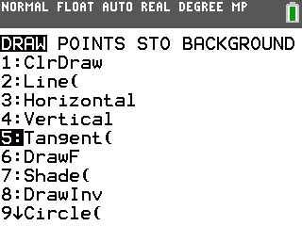
The calculator draws the tangent line and displays the equation of the line. Record the x-value and the slope of the tangent line.

- x: ________________

- slope of tangent: ________________
Now find the value of the function f(x) = 2^{x} at the same point. Press 2nd trace to open the CALCULATE menu. Select 1:value. Enter the x-value you recorded. Press enter.
The calculator displays the y-value of the function at this point. This is the value of the function for this value of x.
- f(x): ________________

- How does the slope of the tangent line at this point compare to the value of the function, f(x)?

Return to the y = screen. Change the value of b to a nonnegative number of your choice and graph the new function. Draw a tangent line at any point on the graph of f(x).
Record the values of b, x, f(x), and the slope of the tangent line at x in the table below along with your earlier observations.
b | x | f(x) | slope of tangent at x
2
3

Return to the y = screen and change the value of b again. Draw a tangent line for each curve and record your results in the table.
- Write at least two observations about the graph and/or the slope of its tangent at T.

Problem 3
Slope is a measure of rate of change in a function. In this example, sometimes the slope is less than y, and sometimes it is greater than y. There is only one value of b for which the rate of change of the function y = b^{x} at any point is equal to the value of the function itself. Can you find an approximate value of this number?  When the rate of change of y = b^{x} is equal to the value of the function, the ratio will equal one.
  b
  2
  3
To begin the search for this value of b, use the data you have collected to complete the table.
Value of b that is closest to 1 and greater than 1: _____
Value of b that is closest to 1 and less than 1: ______
The value of b we are looking for must be between these two.
Choose some values of b that are between two numbers and repeat the process of graphing the function, drawing a tangent line, recording the value of the function and the slope of the tangent line at that point, and calculating the ratio. Narrow in on the value of b that yields a ratio of 1 as closely as you can.
b | x | f(x) | slope of tangent at x

What is this value of b? b ≈ _________

Applications
The number you found is an approximation for the mathematical constant e. As you discovered, it is unique in that it is the only value of b such that y = b^{x} changes at a rate that is equal to the value of the function itself. It also shows up in a number of functions that model natural phenomena.
Some examples are:
(a) the growth of populations of people, animals, and bacteria;
(b) the value of a bank account in which interest is compounded continuously;
(c) and radioactive decay.
The common feature is that the rate of growth or decay is proportional to the size of the population, account balance, or mass of radioactive material. Growth and decay situations can be modeled by equations of the form P = P₀e^{kt}, where P is the current amount or population, P₀ is the initial amount, t is time, and k is a growth constant. An amount is growing if k > 0 and declining if k < 0.
The following are examples of exponential growth or decay. For each exercise, write an equation to represent the situation and solve your equation to find the answer.

1. Suppose you invest $1,000 in a CD that is compounded continuously at the rate of 5% annually. (Compounded continuously means that the investment is always growing rather than increasing in discrete steps.) What is the value of this investment after one year?
Two years? Five years?

2. A colony of bacteria is growing at a rate of 50% per hour. What is the approximate population of the colony after one day if the initial population was 500?

3. Suppose a glacier is melting proportionately to its volume at the rate of 15% per year. Approximately what percent of the glacier is left after ten years if the initial volume is one million cubic meters? (This is an example of exponential decay.)

4. A snowball is rolling down a snow covered hill. Suppose that at any time while it is rolling down the hill, its weight is increasing proportionately to its weight at a rate of 10% per second. What is its weight after 10 seconds if its weight initially was 2 pounds? After 20 seconds? After 45 seconds? After 1 minute? What limitations might exist on this problem?

