Open the TI-Nspire™ document Treasure_Trove.tns.  Imagine digging for buried treasure and finding thousands of pennies. This amount of treasure might weigh much more than you could carry! In this activity, you will use answer the following question: If you could keep all the treasure in pennies that you could lift, would you bury your treasure on Earth, the moon, Mars, Saturn, or Jupiter? | 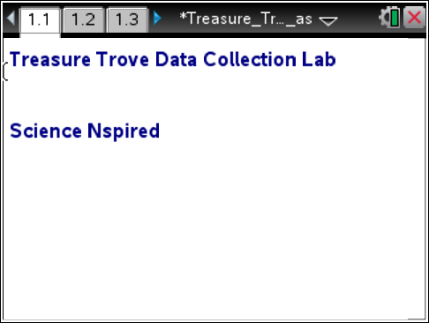
Read the background information for this activity.

The mass and weight of an object are two different properties. The mass of an object stays the same no matter where it is located. Mass is the amount of matter measured in grams or kilograms. Weight on Earth is a measure of the gravitational pull between Earth and the object on Earth’s surface. Because the gravitational force on other celestial bodies is different than it is on Earth, the weight of an object will change if it moves to different parts of the solar system.
For example, the weight of 100 pennies would be different on Earth and the moon. This is because the gravitational pull on the moon is weaker than it is on Earth. A force sensor measures the weight of an object in Newtons. If you know how much 100 pennies weigh on Earth, you can figure out how much they weigh on the moon, Mars, Saturn, and Jupiter.

Move to page 1.2.

1. Using a Styrofoam cup and string, make a scale to hold the pennies. Hook your scale onto the force sensor.
2. Hold the force sensor on a table with your hand or attach it to a ring stand. The cup must swing free of the table or stand.

Move to page 1.3.

3. Plug the force sensor into the Vernier EasyLink or TI-Nspire Lab Cradle and connect to the TI-Nspire technology. (Make sure that the Styrofoam cup scale is in position and is not moving.)

4. Select Mode: Events with Entry. Then select the Start button. |  |  |  |  |  |  |  |  |  | 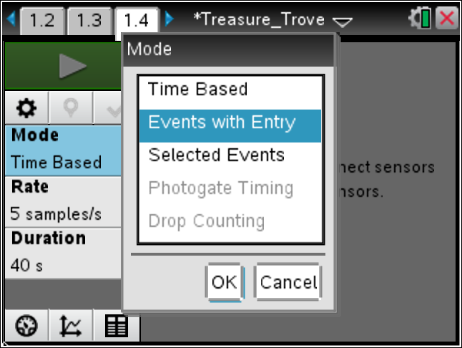
5. When the reading has stabilized, select the Keep button.
6. The program asks you to enter a value. This value is the number of pennies in the cup, NOT the force. Type the number of pennies and select OK. The program returns to the data collection screen, ready for the next data point.
7. Add 10 pennies to the cup and wait for the cup to stop swinging.
8. Repeat steps 5 through 7 until you have 100 pennies in the cup. Use the number of pennies in the cup when the program asks for a value after you select Keep button. After you enter the first number, the last value you used is displayed under the entry box.
9. After you have collected the data for 100 pennies in the cup, select the Stop button. A scatter plot is displayed showing the number of pennies and force reading for all of your tests. Click Table View to display the data table on the handheld. Record the values in the table below.

 | Number of Pennies | Force (Newtons) |  |  |  | Force (pennies) – Force (cup)
 | 0
 | 10
 | 20
 | 30
 | 40
 | 50
 | 60
 | 70
 | 80
 | 90
 | 100
10. Subtract the weight of the cup (number of pennies = 0) from each value in the table and record the actual weight of the pennies in the last column of the table.

11. Select Graph View to view the graph of your data. Sketch and label the graph showing the number of pennies and the force readings. |  |  |  |  |  |  |  |  | 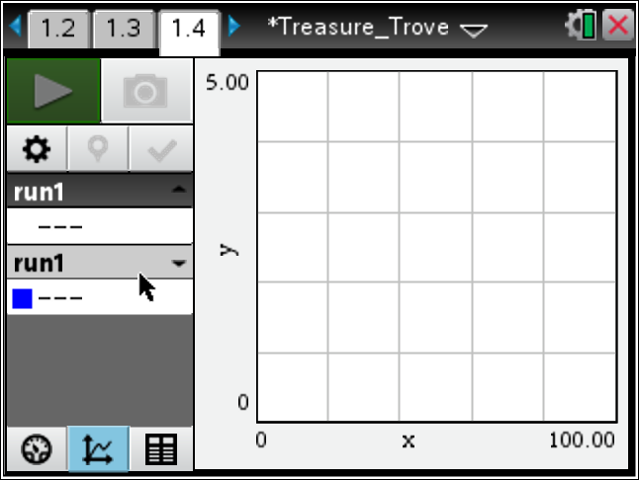
Move to pages 1.4 - 1.8.
Answer questions 1 - 5 below and/or in your .tns file.

Q1. Observe the graph showing the number of pennies and the force readings. What does the point on the y-axis where the number of pennies = 0 represent?

Q2. As the number of pennies increases, what happens to the force of gravity or their weight on Earth?

Q3. What correlation does the graph show between force/weight in Newtons and the number of pennies?

Q4. What is the average rate of change in force for every 10 pennies added to the cup? How did you figure this out?

Q5. On Earth, how much would 1,000, 10,000, 100,000, and 1,000,000 pennies weigh in Newtons?

Move to page 1.9.

12. Use the gravity conversion factors to complete the table of how much the pennies would weigh on the moon, Mars, Saturn, and Jupiter. (Use your answers from Question 5 to complete the data for the Earth.) For example, a treasure hunter could lift six times the weight on the moon as on Earth. This is because the moon has a smaller mass and diameter so the weight in Newtons of the treasure is only 1/6 as much as on Earth.

 | Celestial Body | Gravity Conversion Factor |  | Weight of Pennies in Newtons
 |  |  |  | 100 pennies | 1,000 pennies |  |  | 10,000 pennies |  |  | 100,000 pennies | 1,000,000 pennies
 | Earth | 1.00
 | Earth’s moon | 0.17
 | Mars | 0.38
 | Saturn | 0.92
 | Jupiter | 2.36
Move to pages 1.10 - 1.14.
Answer questions 6 - 10 below and/or in your .tns file.

Q6. For every 10 pennies you lift on Earth, you can only lift about 4 pennies on Jupiter. Explain why this statement makes sense.

Q7. Fill in the blanks: The mass of 100 pennies will be __________________ at every location in the universe. The weight of 100 pennies is different. Since weight is a result of the pull of gravity on a mass, the weight of 100 pennies would ____________ depending on its location. Weight on Earth is a measure of the ____________ force between the Earth and the 100 pennies and the distance of the pennies from the center of the __________________. Since the mass of Earth’s moon is smaller, it exerts only 1/6 of the Earth’s gravity on the pennies. Therefore, 100 pennies should weigh __________________ on the moon.

Q8. Fill in the blanks: The weight of 100 pennies will __________________ in different locations. __________________ is a measure of the gravitational force between the mass of Earth, the moon, Mars, Saturn, or Jupiter and the pennies. The different masses and diameters of these celestial bodies cause different amounts of __________________ pull on the pennies. The pennies also pull back on the large bodies.

Q9. Fill in the blanks: 100 pennies weigh the least on ____________________. This is because the ____________________ and diameter are ____________________ so the gravitational pull on the pennies is _________________________________ .

Q10. Fill in the blanks: 100 pennies weigh the most on ____________________. This is because the ____________________ and diameter are ____________________ so the gravitational pull on the pennies is _________________________________ .

Move to pages 1.15 – 1.16.
To answer question 11, complete the table below and/or in your .tns file.

Q11. If you could lift 100 pounds (approximately 450 N) of pennies on Earth, how many pennies could you lift on each of the other celestial bodies? How much money would that be in each case?

 | Celestial Body |  | Number of Pennies You Could Lift |  |  |  | Amount of Money You Could Lift
 | Earth’s moon
 | Mars
 | Saturn
 | Jupiter
Move to pages 1.17 - 1.18.
Answer questions 12 - 13 below and/or in your .tns file.

Q12. If I could keep all the treasure in pennies that I could lift, I would bury my treasure on:

Q13. If a treasure hunter can lift 50 pounds of pennies on Earth, what is the maximum number of pounds this person can lift on each of the other celestial bodies? (Round to the nearest pound.)

__________ pounds on Earth’s moon

__________ pounds on Mars

__________ pounds on Saturn

__________ pounds on Jupiter

