Open the TI-Nspire document Recipe_for_a_Living_World.tns.  Very few recipes have an ingredients list that is so short or so simple. The recipe card could read like this:  1. Take equal parts carbon dioxide, gas, and water.  2. Allow the CO₂ and H₂O to meet inside a plant cell.  3. Expose the plant cell to light.  4. Make sure the correct equipment is available in the plant cell, and that the temperature is right.  5. In only a few minutes, you will have some sugar and some oxygen gas. Get rid of the oxygen and feed Planet Earth with the sugar!  6. Repeat. |  |  |  | 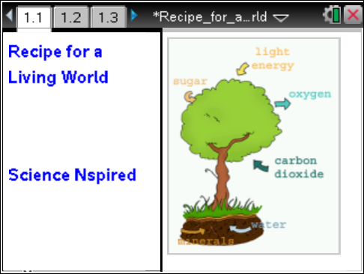
Seriously? Who would believe this?! And yet, it’s true! Plants, as well as some simpler organisms such as algae, carry on photosynthesis. This process involves using a gas (CO₂) from the air, liquid water (H₂O) from the ground, light energy, and some cellular equipment and supplies. The end result is to produce enough food for almost every organism on Earth—including themselves! Next time you look at a plant and think to yourself, “BORING! They just stay in one place and don’t do ANYTHING!” – think again! There is enough going on inside that plant to put the busiest kitchen to shame!
Many variables affect the rate and efficiency of photosynthesis. In the first simulation, you will adjust and observe the effect of the color (wavelength) of visible light on the rate of photosynthesis. In the second simulation, you will manipulate the intensity of the light on a plant and observe how this variable impacts photosynthesis rates.
Move to pages 1.2–1.3.
Read the background information on page 1.2.
1. On page 1.3 you will see a picture of a leaf with 6 stomata that will be used as a monitor of the rate of photosynthesis as the illuminance (or intensity) of light is increased. In real life, stomata are microscopic, and there are often thousands of them on one leaf. During this simulation, the more stomata are open, the greater the rate of photosynthesis. Pay attention to the stomata as you make your adjustments.
2. When you are ready, click on the start arrow . Then click on the “up arrow” to change the wavelength of light (λ) to which the leaf is exposed. Again, watch both the stomata and the illuminance value as you proceed. Continue to increase the wavelength until it will no longer change, then move to the graph on page 1.4.

Move to pages 1.4–1.5.
Q1. Sketch your graph in the space to the right. To reset the simulation and run it again, click on the reset button .

Move to pages 1.6–1.8. Answer the following questions here or in the .tns file.
Q2. As the light intensity increases, the rate of photosynthesis __________.
A. increases | B. decreases |  | C. stays the same
Q3. As the rate of photosynthesis increases, which of the following substances would you expect to decrease?
A. oxygen  B. carbon dioxide |  | C. glucose  D. chlorophyll
Q4. During which of the following months would you expect photosynthesis rates to be highest in the Southern Hemisphere?
A. January  B. April |  | C. June  D. August
Move to page 2.1–2.5.
Read the brief background information on page 2.1.
3. On page 2.2, you’ll see another picture of a leaf with stomata. However, for this simulation, you will change the wavelength of visible light to which the leaf is exposed. The visible spectrum (ROYGBIV) is displayed across the top of the screen. As with the simulation in Problem 1, the more stomata that are open, the greater the rate of photosynthesis. Pay attention to both the spectrum and the stomata as you make your adjustments. When you are ready, select the start arrow . Then click on the “up arrow” to change the wavelength. Changing wavelength changes the color, of the light to which the leaf is exposed. After you reach the upper limit of the wavelength (780 nm), move to pages 2.3 and 2.4 and observe the graphs that were generated.

Q5. Sketch both graphs in the spaces to the right.

Q6. Explain why the graphs look the way they do.
Photosynthesis Rate:

CO₂ Level:

Q7. Why do you think ROYGBIV was displayed backward on page 2.2?

Q8. Which wavelengths of light were best for photosynthesis? How can you tell?

Q9. Which colors of light were best for photosynthesis?

Q10. Which wavelengths of light were least used for photosynthesis?

Q11. Which colors of light were least used for photosynthesis?

Q12. How does your answer to Question 11 explain the color of most plants?

Q13. During the simulation, how could you tell which wavelengths were best for photosynthesis and which ones were not?

Q14. What would happen if a plant were exposed ONLY to green light? Why?

Q15. Describe a place on Earth where photosynthesis rates would tend to be consistently very high. Explain.

