Explore transformations and dilations with a fish you will create.
Part 1 – Plotting a Fish
- List the ordered pairs for the fish on the graph to the right. Start at the snout of the fish and move clockwise in the order shown below. Of the 24 ordered pairs used to make the fish, the remaining coordinates are integers. Some points are repeated.  Enter the data into L1 and L2 in the above order. The first point and the last should be the same. Use S Edit to access the lists. Set the window settings as shown to the right such that the x-values range from 0 to 18 and the y-values range from 0 to 12. Press ` ! to turn on the Stat Plot. Press ` # to access é to turn on the gridline and set up color on the TI-84C.  - How could you change coordinates to move the fish left three units? (Think about where the new snout of the fish would be and what you would have to do to the coordinates to move it there.)  - How would you change the coordinates to move the fish up two units?  - How would you change the coordinates to move the fish to the right four units and down three units? |  | 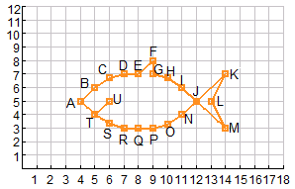  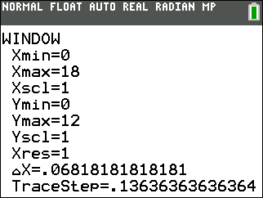  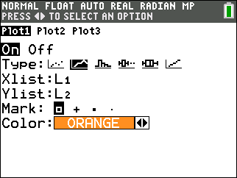  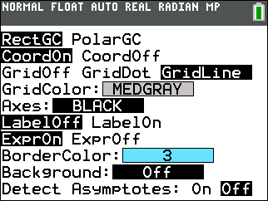
  A ( 4 , 5 ) | I ( , 6 ) | P ( , )
  B ( 5 , ) | J ( , ) | Q ( , )
  C ( 6 , 6.7) | K ( 14 , ) | R ( , )
  D ( , ) | L ( , ) | S ( 6 , 3.4 )
  E ( , ) | M ( , ) | T ( 5 , 4 )
  F ( , ) | J ( , ) | U ( , )
  G ( , ) | N ( , ) | T ( 5 , 4 )
  H ( 10, 6.7) | O ( 10 , 3.3 ) | A ( 4 , 5 )
Part 2 – Move the Fish
On the Home screen – press ` M to î out of a graph or other screen – you will perform some operations on lists. First, turn on Plot 2 as shown to the right. To do this press ` ! for StatPlot. Press ` 3 and ` 4 to get L3 and L4.  To enter the arrow, press =.  Sketch your graph of L3 and L4 below. Press % to help you sketch the graph. |  | 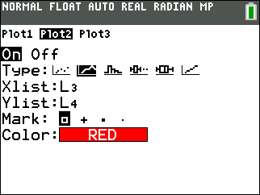
- L1 + 3 á L3  L2 á L4 |  | - L1 – 4 á L3  L2 á L4
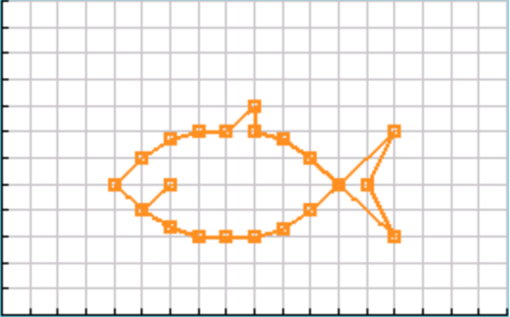
- Describe the effect of the change in each of the above. How did the fish move? What happens when a number is added to or subtracted from the x-values of a figure? Is the new fish congruent or similar?

- L1 á L3  L2 + 2 á L4 | - L1 á L3  L2 – 3 á L4

- Describe the effect of the change in each of the above. How did the fish move? What happens when a number is added to or subtracted from the y-values of a figure? Is the new fish congruent or similar?

Change the window settings to see all four quadrants as shown to the right. Change the Xscl and Yscl to 2 so that there is a tick mark every two units. Press ` ! and change the Stat Plot points from squares to dots.  - What transformations would you need to do to the original coordinates in order to produce the fish in the third quadrant show to the right?  - Describe the transformation you would do to move the snout of the fish to (−5,0). Do this transformation by storing the coordinates of your fish in L3 and L4. Record what you stored below. | 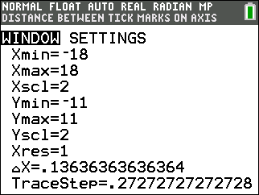  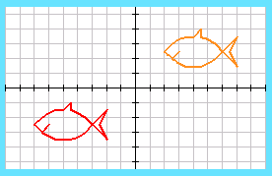
Part 3 – Grow Fish
Turn on Plot 3. The x-values are L5 and the y-values are L6. You will perform operations on L3 and L4 to dilate the fish you made near the origin, with its snout at (−5, 0). Again you will use ` 5 and ` 6 to get L5 and L6, and press = for the arrow.  Sketch your graph of L5 and L6 below. Press % to help you sketch the graph. | 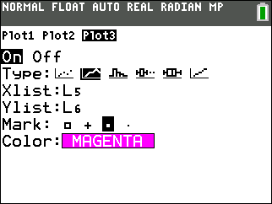
- 2L3 á L5  2L4 á L6 | - ½ L3 á L5  ½ L4 á L6
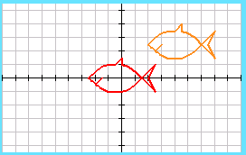
- How did the fish change? What happens when a number is multiplied by the x-values and y-values of a figure? Is the new fish congruent or similar?

- Consider the following operations: rotations, reflections, translations, dilations. Which operation will yield a similar figure? Explain.

- Consider the following operations: rotations, reflections, translations, dilations. Which operation will yield a congruent figure? Explain.

