Open or create the TI-Nspire™ document Exploring_Diameter_and_Circumference.tns.  In this activity, you will capture data to explore the relationship between the circumference and diameter of a circle. | 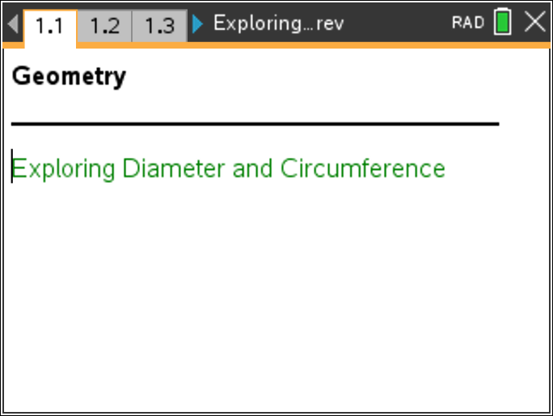

Part 1 – Exploring the relationship between the diameter and circumference of a circle  Move to page 1.2.
  Press / ¢ and / ¡ to navigate through the lesson
- The London Eye is a large Ferris wheel in London. On page 1.2, you see a photograph of the London Eye with a circle constructed on it.  - Grab the open point at the end of the segment. Observe what happens when you drag that point onto the circle.  - Record your data in the table shown at the right.  - Repeat Steps 2 and 3 for pages 1.3 and 1.4. You can calculate the value of C/d by pressing Menu > Actions > Calculate and then clicking on C/d and following the directions on the screen.  - Make a conjecture about your observations. | 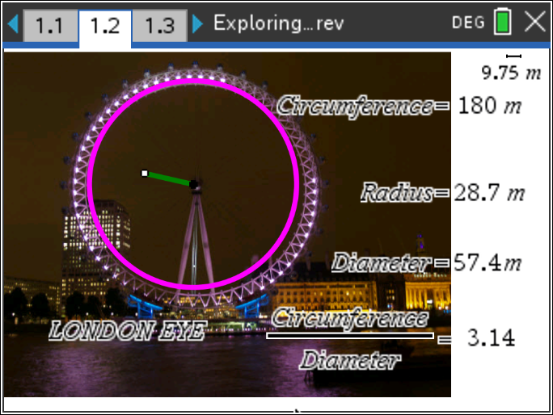
  Circumference
  Diameter (d)
  C/d
  Circumference
  Diameter
  C/d
  Circumference
  Diameter (d)
  C/d

Part 2 – Collecting data about the diameter and circumference of a circle  Move to page 2.1  - On the left side of page 2.1, you see a circle, a diameter of the circle, and measurements for the circumference and diameter of the circle. The right side of page 2.1 shows a spreadsheet where data will be collected.  - Drag one of the points on the circle to change the diameter. What do you observe? | 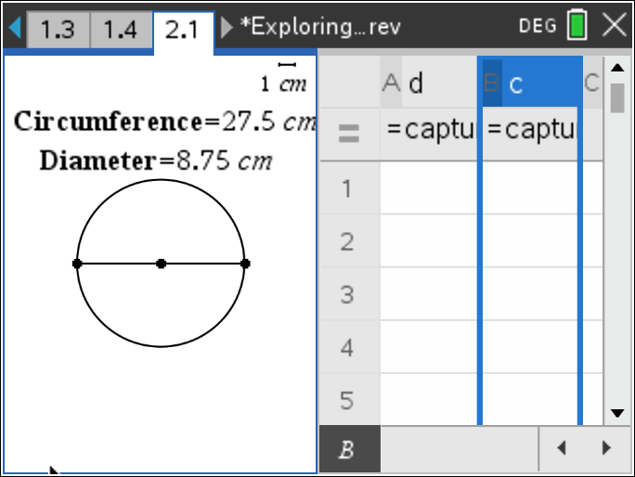  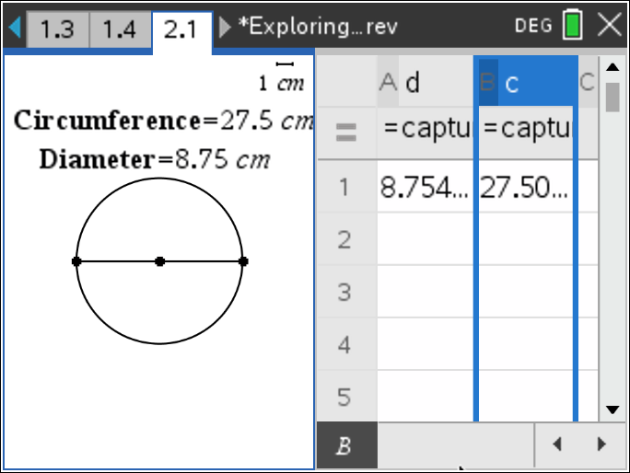
- To collect data, drag one of the points on the circle to change the diameter and press / and ^. This will populate row 1 in the spreadsheet for the diameter, d, and the circumference, c, values.
- Move the point again and press / and ^ to collect more data.
- Repeat above step until 5 rows of data are filled in the spreadsheet.  - Press / e to move to the spreadsheet on the right side of the screen. If necessary, move the cursor over the cells to read the values. Record your data in the table shown at the right.
   | d | c
  1
  2
  3
  4
  5
- a. What do you observe about the measurements of the diameter, d, and the circumference, c?

- Make a conjecture about the relationship between the variables c and d. (Use the words circumference and diameter in your conjecture.)
- Move the cursor to the formula cell (= row) in Column C as shown in the figure at the right.  - Press = h, use £ or ¤ to highlight c and press · or x.  - Press p h, use £ or ¤ to highlight d and press · or x.  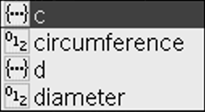  - Press · to calculate the values in Column C. | 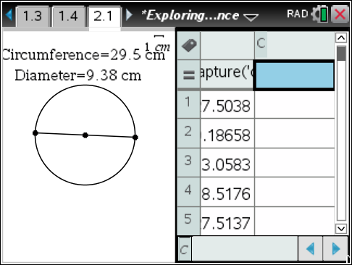
- a. What do you observe about the values in Column C?

b. How does this relate to your answer in question 12?

Long ago, mathematicians named the ratio of circumference to diameter with the Greek letter π (pi). Complete the statements below.
- If C is the circumference of a circle and d is the diameter of the circle, then there is a number π such that C = ______. Also, in terms of the radius r of the circle, C = ______.

Part 3 – Using a scatter plot (diameter vs. circumference) to explore the relationship  - Press / ~ > Add Data & Statistics.  - Press Menu > Plot Properties > Add X Variable.  - Select variable d to add the variable d on the horizontal axis.  - Press Menu > Plot Properties > Add Y Variable.  - Select variable c to add the variable c on the vertical axis. | 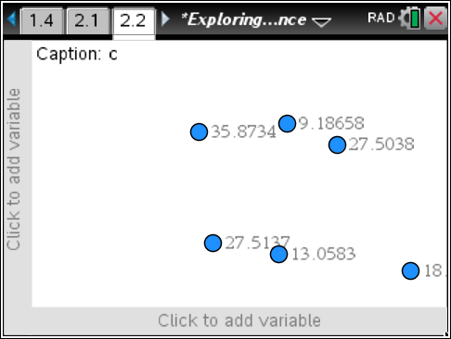
- In which quadrant do all points lie? Why?

- What type of equation would be a good fit for these data points?

- Consider the ordered pair (diameter, circumference). If you could have a circle with a diameter of 0 units, what would be the corresponding circumference? (0, ____)

- Press Menu > Window/Zoom > Window Settings. Enter the numbers as shown at the right. Then tab to OK to close the window. | 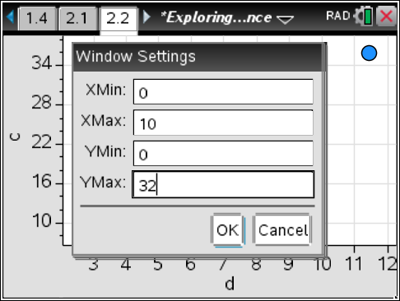
- Press Menu > Analyze > Add Movable Line.
- Position the cursor over the line until you see ö. Grab the line and move it up or down until it passes through the point (0, 0). Press x.
- Position the cursor over the line until you see é. Grab the line at the top right and rotate it until it closely matches the data.
- What is the equation of this line? m1(x) = __________________

- a. What is the slope of this line?

b. What does the slope represent?

- If a circle has a diameter of 50 cm, what is its circumference? How do you know?

- If a circle has a circumference of 50 cm, what is its diameter? How do you know?

