Problem 1 – One Midsegment
Open a new CabriTM Jr. file. Construct a triangle using the Triangle tool.  Select the Alph-Num tool to label the vertices A, B, and C as shown.  Note: Press Í to start the label, and then press Í again when you are ready to end the label. |  | 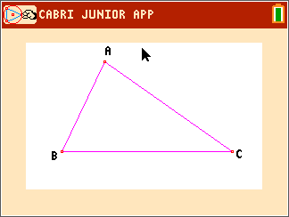
Construct the midpoints of two sides of the triangle using the Midpoint tool. Label the midpoints D and E.  Save this file as Midseg. This setup will be used again in Problem 2. |  | 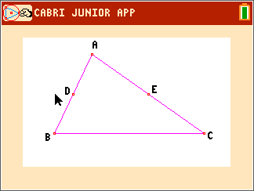
Select the Segment tool and construct . |  | 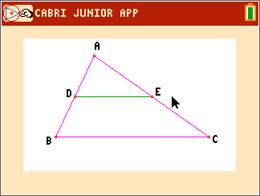
1. Use the D. & Length, Angle, and Slope tools in the Measure menu to explore the properties of the midsegment. Fill in the blanks below.

Length of _____ = ________ Length of _____ = ________
Measure of ∠ _____ = ________ Measure of ∠ _____ = ________
Slope of _____ = ________ Slope of _____ = ________

2. What conjectures can you make about the midsegment and its relationship to ABC? Be sure to drag the vertices of ABC around the screen to confirm your conjectures.

Use the Calculate tool to find the ratio of the lengths of sides BC and DE. Select the measurement of BC, then press the division symbol, and then select the measurement of DE. Move the ratio to an open space on the screen and press Í.
3. Drag a vertex of ABC and observe the results.
Length of = __________ Length of = __________
Length of = __________ Length of = __________
Ratio = __________ Ratio = __________

4. Complete the conjectures.
The length of the midsegment is ______________________________________.
The slope of the midsegment is ______________________________________.

5. What is the relationship between ADE and ABC? How would you prove it?

Problem 2 – Three Midsegments
Open the Cabri Jr. file Midseg created in Problem 1.  Create the midpoint of the third side of the triangle and label it F. |  | 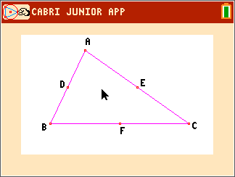
Construct DEF using the Triangle tool. |  | 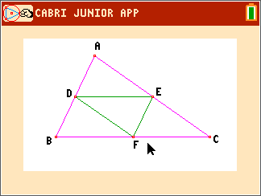
6. Use the D. & Length and Area tools in the Measure menu to measure the perimeter and area of DEF and ABC.
Perimeter of ABC = __________ Area of ABC = __________
Perimeter of DEF = __________ Area of DEF = __________

Use the Calculate tool to find the ratio of the perimeters and areas. Take the larger value and divide by the smaller value.  7. Drag a vertex of ABC and observe the results.  Ratio of Perimeters = __________  Ratio of Areas = __________ |  | 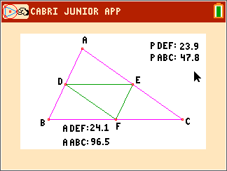
8. What is the relationship between DEF and ABC? How would you prove it?

9. What is the relationship between DEF and ADE? How would you prove it?

Apply the Math
Use this diagram for each exercise.  D, E, and F are all midpoints.  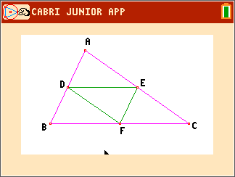 | 10. If DE = 6.2 inches, and AB = 11.4 inches, find the lengths of and .  11. If the perimeter of ABC is 32 cm, find the perimeter of DEF.  12. If the area of DEF is 8.6 cm², find the areas of ABC, ADE and BDF.  13. If m∠AED = 27° and m∠A = 64°, find as many other angle measures as possible.

