One major kind of problem for which statistical methods are used is estimating the average value of some quantity. In this activity, you will explore three different methods for carrying out such an estimation. | 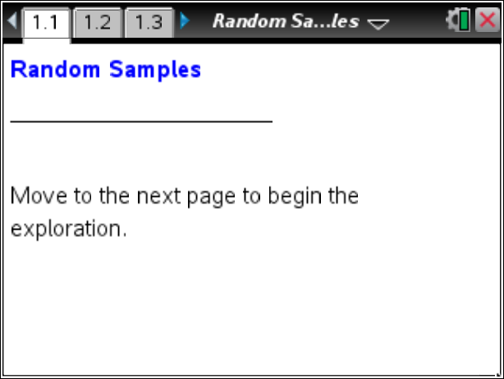

You will be given a handout, face down, that contains the images of exactly 100 rectangles of various sizes.
Do not look at the handout until you are instructed to do so.

Your task throughout this activity will be to obtain an estimate for the mean of the areas of all 100 rectangles.
One method for estimating the mean area is simply to look at the whole set of rectangles and make an educated guess based on what you see.
1. When you are told, turn the handout face up. You will have 10 seconds to examine the rectangles and arrive at a reasonable estimate for the mean of the areas of the 100 rectangles. When time is called at the end of 10 seconds, turn your handout face down again. Write your estimate below.

_______________ = mean of areas.

Another way to estimate the mean area of all the rectangles might be to take a sample of the actual rectangles on the sheet and find the mean area for the sample.
2. When you are told, turn the handout face up again, and visually select exactly five rectangles you think would be a representative sample. Note the ID number and the area of each rectangle you select. Record your data below. Find the mean area of your sample, keeping any digits past the decimal in your mean. Turn your handout face down again.

ID Area Mean Area of Sample
______ ______
______ ______ _______
______ ______
______ ______
______ ______

Open the TI-Nspire™ document Random_Samples.tns.

Move to page 1.2. | Press / ¢ and / ¡ to navigate through the lesson.
Tip: This activity involves generating a number of random samples from a population. In order to avoid having your results be identical to those for another student in the room, it is necessary to “seed” the random number generator. Read the instructions on Page 1.2 for seeding your random number generator, and then carry out that seeding on Page 1.3.

The sample you selected in Question 2 was what the media usually call an “unscientific” sample. Statisticians would call it a judgment sample, since you just selected five rectangles you thought were typical. Another kind of sample that statisticians use is called a simple random sample.
3. You will use the Scratchpad on your handheld to select five random rectangle ID numbers, as follows. Open a Scratchpad Calculator page. Type the command randint(0,99,5), and press ·. You should see five ID numbers as output. Turn the handout face up again, locate the five rectangles whose ID numbers were generated, and record their IDs and areas below. Find the mean area of your sample, keeping any digits past the decimal in your mean.

ID Area Mean Area of Sample
______ _____
______ _____ _______
______ _____
______ _____
______ _____

You have now used three different methods to estimate the mean area of the set of rectangles. In statistics, a method is called unbiased if its long-term behavior, on average, is correct. More precisely, if the mean of the estimates produced by the method is actually equal to the value that the method is trying to estimate, then that method is unbiased.
In contrast, the mean of estimates from a biased estimation method would differ from the true value being estimated. Thus the estimates from a biased method will be systematically too high or too low. In general, unbiased estimators are usually more desirable.
4. Which, if any, of the three estimation methods—educated guess, judgment sample, or random sample—do you think might be unbiased? Why?

One way to determine which of the three estimation methods you used to estimate the mean area of the rectangles is best is to compare their results from everyone in your class. Your teacher will help you collect the estimates for the three methods from your classmates.

Move to page 2.1.

5. Examine your class’s estimated mean areas from the three methods, compiled in the respective spreadsheet columns on Page 2.1. Based on looking at just the numbers, does it seem that any particular method is more consistent than the others?

Move to page 2.2.

6. Page 2.2 displays three dot plots with your class’s results from the three different methods of estimating the mean area of the rectangles. Compare the three distributions with respect to center, spread, and shape. Which estimation method seems best?

Move to page 2.3.

7. Page 2.3 shows the same dot plots you saw on Page 2.2, but now a vertical line has been added to the plot.
a. Click on the vertical line. What information does it convey?

b. Based on this new information, which estimation method seems best? Explain.

Move to page 3.1.

8. Page 3.1 permits you to take many random samples of size five.
a. Click the right arrow to select one random sample. Describe the contents of each panel on the screen, and interpret them in terms of the areas of the rectangles.

b. Continue to select more samples until a clear pattern emerges in the lower panel. Describe the important features of the distribution, and explain what it means with respect to estimation and bias.

