Problem 1 – Ordered Pairs
1. a. For the point (−2, 6), the first number, −2, is the ____-coordinate (or the abscissa).
b. For the point (−2, 6), the second number, 6, is the ____-coordinate (or the ordinate).
To graph a point, enter the coordinate in L1 and L2. Then turn Plot1 on and display the graph.  For example, to graph (1, 4), press  . Then enter 1 in L1 and 4 in L2. Press   and match the settings shown at the right. Press  and select ZStandard. |  |  | 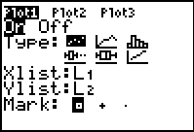
2. a. The point (1, 4) is in the first quadrant. In which quadrant is (1, −4)?
b. In which quadrant is (−5, 2)?
c. In which quadrant is (−3, −2)?
d. In which quadrant is (4, 4)?
e. In which quadrant is (−4, 0)?
f. In which quadrant is (3, 5)?
To explore ordered pairs, press □ and make sure all the equations are cleared and Plot1 is off. Then, press and use the arrow keys to move the cursor.  3. a. Where are the coordinates (negative, positive)?  b. Where are the coordinates (positive, negative)? |  |  | 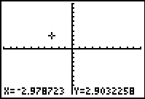
c. Where is the ordered pair when it is (positive, positive)?

d. Where is the ordered pair when it is (negative, negative)?

Plot the following ordered pairs on the graph at the right. Label each pair with the appropriate letter.  A(−1, 3) K(4, −2) O(−2, −2)  C(1, −3) M(−4, 4) R(−5, −1)  H(5, 1) S(6, −1) T(2, 2)  4. What phrase do the points spell? | 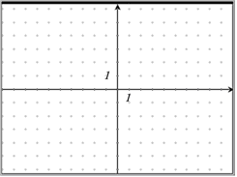
Problem 2 – Order Pears
Math is everywhere. At the market, the equation y = 1.5x represents the cost to buy x number of pears, where y is the cost in dollars.
For example, you order 8 pears. The cost is $12. This can be written as the ordered pair (8, 12).
5. Your order came to $3. How many pears did you order?

6. Enter 5 ordered pairs for the cost of ordering pears using L1 and L2. If data already exists, arrow up to the top of the list and press   to clear the data.  Create the scatter plot and record your observation. |  | 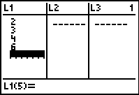
7. Press □. Graph the function f(x) = 1x in Y1. Change the slope of the function (currently 1) until the line matches the points. What is the slope of your line? How does it relate to the problem?

Extension
You saw that values of a function can be written as a set of ordered pairs, listed in a table of values, and graphed as a scatter plot.
Extension 1: Find some other real-life data. Represent it as a set of ordered pairs, table, and scatter plot.
Extension 2: Come up with your own puzzle like the one at the bottom on page 1 of this worksheet that you can share with a friend and your teacher.

