Open the TI-Nspire document Graphs_of_the_OTHER_Trig_Functions.tns.  You probably know a lot about sine, cosine and tangent, but you might not know as much about the other trigonometric functions, cotangent, secant, and cosecant. In this activity, you will explore those functions, learn what their graphs look like, and why they look the way they do. | 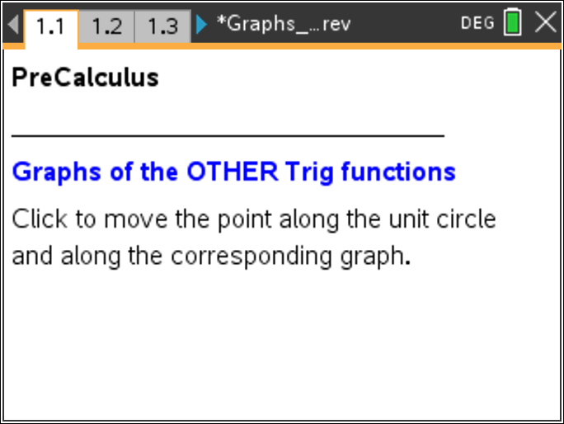

Move to page 1.3. | Press / ¢ and / ¡ to navigate through the lesson.
1. The screen shows a unit circle, and you can use the clicker to move a point around the circle, changing the angle θ. Change the angle θ to be equal to 35°, as pictured on the right. This creates two right triangles: The one on the top with one leg on the y-axis, one leg the bolded line segment, and the one on the bottom with one leg on the x-axis and one leg the dashed line segment.  - Prove that these two triangles are similar. | 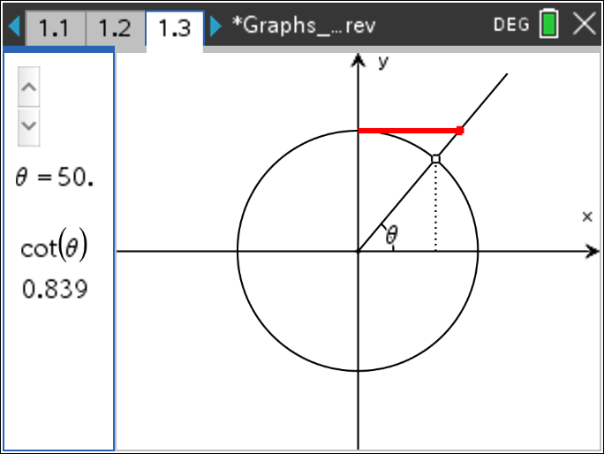
- Using the ratios of the non-hypotenuse side lengths, determine the length of the bolded side in terms of the other legs of the triangles. Don’t forget that you are working on a unit circle!

2. You may now change the angle and explore on your own.
a. Recall that we can write the trig functions in terms of the sine and cosine functions. What is the cotangent function in terms of the sine and cosine functions?

b. Click to move the point around the circle. What does the bold line segment length represent? How is it determined? How do you know?

c. For what values of θ is the cotangent 0? Undefined? Why?

- Describe or sketch what you think the graph of the cotangent function might look like. Explain your thinking.

Move to page 2.2

3. The left hand side of the screen shows the unit circle from Page 1.3, and the right side shows the graph of the cotangent function.
a. How does the graph of the cotangent function compare to your description in question 1? If your prediction was incorrect, what do you think was your mistake?

b. What happens as you click the arrow to change the value of θ? Why does the graph “jump” from one piece to another?

c. Why does the graph repeat itself? As θ increases, how many times do you expect the graph to repeat? Why?

Move to page 3.2

4. a. Recall that we can write the trig functions in terms of the sine and cosine functions. What is the secant function in terms of the sine and cosine functions?

b. Click to move the point around the circle. What does the bold line segment length represent? How is it determined?

c. For what values of θ is the secant 0? Undefined? Why?

d. Describe or sketch what you think the graph of the secant function might look like. Explain your thinking.

Move to page 4.2

5. The left hand side of the screen shows the unit circle from Page 3.2, and the right side shows the graph of the secant function.
- How does the graph of the secant function compare to your description in question 3? If your prediction was incorrect, what do you think was your mistake?

- What happens as you click the arrow to change the value of θ? Why does the graph “jump” from one piece to another? Why doesn’t the graph ever cross the x-axis?

Move to page 5.2

6. a. How can you write the cosecant function in terms of the sine and cosine functions?

b. Click to move the point around the circle. What does the bold line segment length represent? How is it determined?

c. For what values of θ is the cosecant 0? Undefined? Why?

- Describe or sketch what you think the graph of the cosecant function might look like. Explain your thinking.

Move to page 6.2

7. How does the graph of the cosecant function compare to your description in question 5? Explain.

8. Choose one of the three trig functions from this activity. How could you use the graphs of sine and cosine to graph that function? Explain.

