Open the TI-Nspire document Trigonometric_Transformations.tns.  In this activity, you will use an observation wheel to apply transformations to periodic functions and write an equation for a trigonometric function. | 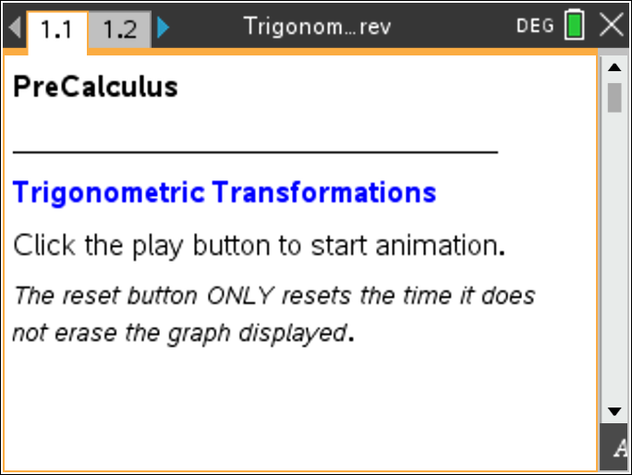

Move to page 1.2. | Press / ¢ and / ¡ to navigate through the lesson.
The London Eye is an observation wheel in London that can carry 800 passengers in 32 capsules. It turns continuously, completing a single rotation once every 30 minutes.
1. On the screen, you see a model of the London Eye on the left side and a graph on the right. Click on the play button to start the animation. Click the button again to stop it. What type of function was created as a result of the animation?

2. What does the changing measurement on the left screen represent as the capsule (represented by the open circle) moves around the observation wheel?

3. What are the units of the x- and y-axes on the right?

4. a. What is the maximum height a capsule reaches from the platform?

b. The horizontal line halfway between the maximum and minimum of the function is called the midline of the graph. What is the equation of the midline? Explain your reasoning.

5. The function y = –A · cos(Bx) + D can be used to model the capsule’s height above the platform at time x. This is a transformation of a basic cosine curve.
a. Use your knowledge of transformations to explain why there is a negative sign in front of the variable A.

b. The variable A represents the amplitude, which is the vertical distance between the midline and the maximum or the minimum. What is the amplitude of the “observation wheel” function, and how did you find the value?

c. Which variable of the equations represents the midline of the function? Explain your reasoning.

d. The period of a function is the time it takes to complete one cycle of a periodic function. What is the period of the “observation wheel” function, and how is it visible in the graph?

6. What characteristic of the observation wheel does the amplitude represent? Explain your reasoning.

7. The variable B represents angular frequency. Angular frequency is the measure of the arc (in radians) traveled by the capsule divided by the time traveled (in minutes).

a. What is the measure of the arc traveled by the capsule in one complete revolution?

b. How long does it take for a capsule to complete one revolution?

c. What is the frequency for the “observation wheel” function?

8. Using y = –A · cos(Bx) + D and the variable information found in Question 5, write the equation representing the height of a London Eye capsule at time x. Verify your answer by graphing the function.

9. Imagine the boarding platform for the observation wheel stands 10 feet above the ground. If your function takes this height into consideration, what parameters of the equation would change? What parameters would stay the same?

