Open the TI-Nspire™ document Function_Composition.tns.  In this activity, you will explore the composition of functions numerically and symbolically. | 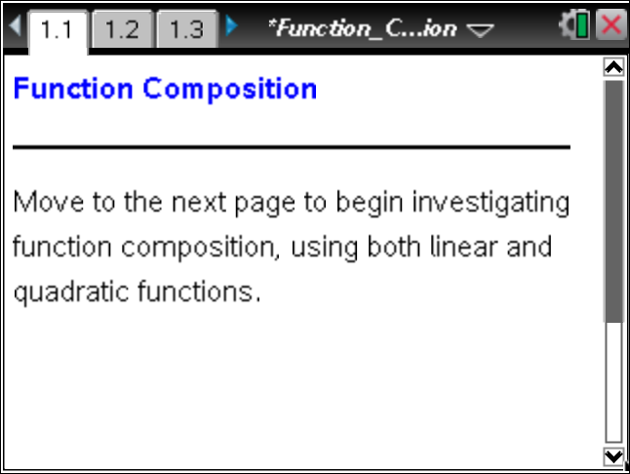

Move to page 1.2. | Press / ¢ and / ¡ to navigate through the lesson.
1. Grab and move the point to change the value of x. Record your observations in the tables provided below.

x | g(x) |  | g(x) | f(g(x))
0
1
2
3

2. Identify the patterns in the tables.
a. What is a possible formula for g(x)?

b. What is a possible formula for f(x)?

3. A function machine can be thought of as a substitution machine. The function (also notated as f(g(x)) and read as “f composed with g of x”) is shown as a double substitution machine. First, x is substituted into the g function. What happens to the result of this substitution?

Move to page 1.3.

4. On page 1.3, there are new functions for f and g. If you grab and move the open point, the handheld will allow only integer values from –9 to 9 to be substituted into the function composition. What is the value of f(g(–10))?

Move to page 1.4.

5. This page shows the g function composed with the f function, notated as g(f(x)). Which function is x substituted into?

6. Given f(x) = x² – 3x and g(x) = 2x + 1:
a. What is the value of g(f(–2))?

b. What is the value of f(g(–2))?

7. Function compositions are not just represented as values in a table. When two functions are composed, the resulting function can be written in terms of x. This can save time if there are many values to substitute into the function composition.
a. The Commutative Property of Multiplication says that Does g(f(x)) = f(g(x))? Why or why not?

b. What is the resulting formula for g(f(x))? Use the resulting formula to find g(f(–2)). Does it match your answer from question 6a?

c. What is the resulting formula for f(g(x))? Use the resulting formula to find f(g(–2)). Does it match your answer from question 6b?

