Problem 1 – Assumptions
Goal: Estimate a population mean.
- When σ is known, the normal distribution and z-scores are used.
- When σ is not known, two assumptions are made:
1. It is a simple random sample.
2. The sample is from a normally distributed population, or n (the sample size) > 30.
If these assumptions are true, use a t distribution. For a sample size n of a t distribution, the degrees of freedom is n – 1.

Graph normal distribution Y1=normpdf(X,0,1).  The normpdf( command is found in the DISTR menu.  Adjust the window appropriately to view the graph. | 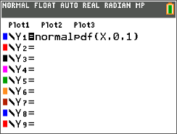
Graph the t distribution for n = 3: Y2=tpdf(X,2).  The tpdf( command is in the DISTR menu.  After viewing the graph, increase the value of n for the  t distribution. View the graph after each increase. | 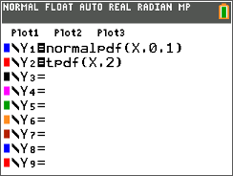
1. What happens as n → 30?

2. How does the size of the sample play a role in the accuracy of the estimation?

The following problems are properties of a simple random sample. Decide which distribution can be used to estimate the population mean and use the calculator commands shown above. Be prepared to justify your answer.
3. Determine whether to use a normal distribution, t distribution, or neither.
a. n = 50, = 10, s = 4, population is skewed.
b. n = 15, = 10, s = 4, population is normally distributed.
c. n = 50, = 10, σ = 4, population is very skewed.
d. n = 15, = 10, s = 4, population is skewed.
Problem 2 – Estimating the Interval
The true mean for the population will almost always be contained in an interval ± E (an error). The error is dependent upon the confidence level chosen. The larger the probability, the larger the interval.
Margin of Error | Confidence Interval
E = | – E < μ < + E
1 – α is the probability that μ (the population mean) is in interval. So, if we desire a 95% confidence interval, then α = 0.05.

4. Find a 95% confidence interval for a sample where n = 25, = 15, and s = 0.5 and the data is normal distributed.

Step 1: Find . Choose the invT( command from the DISTR menu and enter the area and degrees of freedom.  (Area = 0.025, because α = 0.05, and df = 24).  The t-value needed to calculate the error is the absolute value of this number. Find it by choosing abs( from the MATH > NUM menu and pressing ». | 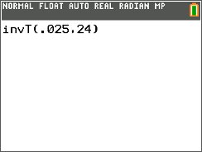
Step 2: Calculate the value of E and store it as E using the ¿ key.  Step 3: Find the interval: – E < μ < + E. | 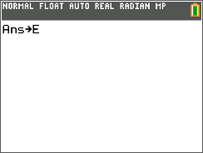
You can use the built-in command, TInterval to find the intervals faster. Choose TInterval from the STAT > Tests menu and enter the information as shown. To calculate the interval, highlight Calculate and press Í. | 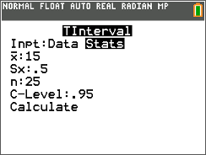
Extension – Using Data
The data in the JANTM list (provided in the chart to the right as well) gives the normal average January minimum temperature in degrees Fahrenheit of 56 cities.  5. Find an interval that estimates the true population mean (average January temperatures for all US cities) with:  a. 90% confidence  b. 95% confidence  c. 99% confidence
  Normal Average January Low Temperatures for 56 Cities
  44 | 35 | 31 | 47
  38 | 42 | 15 | 22
  26 | 30 | 45 | 65
  58 | 37 | 22 | 19
  21 | 11 | 22 | 27
  45 | 12 | 25 | 23
  21 | 2 | 24 | 8
  13 | 11 | 27 | 24
  14 | 27 | 34 | 31
  0 | 26 | 21 | 28
  33 | 24 | 24 | 38
  31 | 24 | 49 | 44
  18 | 7 | 32 | 33
  19 | 9 | 13 | 14

