Math Objectives  - Students will explore the validation of a model constructed from a data set.  - Students will be able to determine a regression equation.  - Students will understand that a pattern in the graph of the residuals indicates that the model is not appropriate for the data set.  - Students will look for and express regularity in repeated reasoning (CCSS Mathematical Practice).  - Students will look for and make use of structure (CCSS Mathematical Practice).  Vocabulary  - data set - linear  - residual - exponential  About the Lesson  - This lesson includes modeling a data set using linear and exponential regressions.  - As a result students will:  - Observe a residual plot as well as a scatter plot of the data.  - Understand that a residual is the actual value of the data minus the predicted value from the regression equation.  - Conjecture and draw conclusions about the appropriateness of the model based on the residual plot.  TI-Nspire™ Navigator™  - Send the TI-Nspire document to students.  - Use Class Capture to view and discuss the scatter plots and residual plots.  - Use Quick Poll questions to adjust the pace of the lesson according to student understanding.  Activity Materials  - Compatible TI Technologies: TI-Nspire™ CX Handhelds,  TI-Nspire™ Apps for iPad®,  TI-Nspire™ Software | 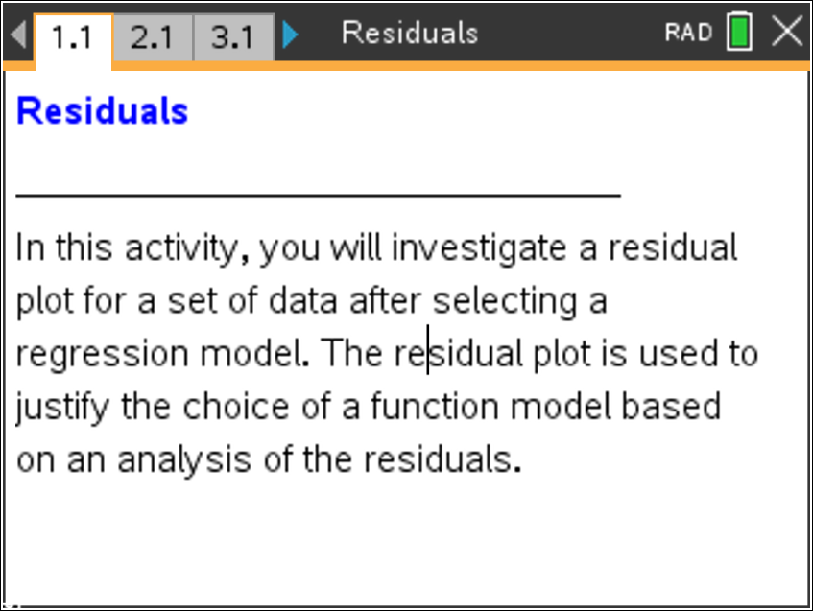  Tech Tips:  - This activity includes screen captures taken from the TI- Nspire CX handheld. It is also appropriate for use with the TI-Nspire family of products including TI-Nspire software and TI-Nspire App. Slight variations to these directions may be required if using other technologies besides the handheld.  - Watch for additional Tech  Tips throughout the activity for the specific technology you are using.  - Access free tutorials at  http://education.ti.com/calcul ators/pd/US/Online- Learning/Tutorials  Lesson Files:  Student Activity  - Residuals_Student.pdf  - Residuals_Student.doc  TI-Nspire document  - Residuals.tns

Move to page 2.1.

Part 1
Use the following data set in Part 1.

$$x$$ | –1 | 0 | 2 | 5 | 7 | 10
$$y$$ | –7 | –4 | –1 | 6 | 8 | 16

- Enter the x values in the column labeled xvalue. Enter the y values in the column labeled yvalue. | 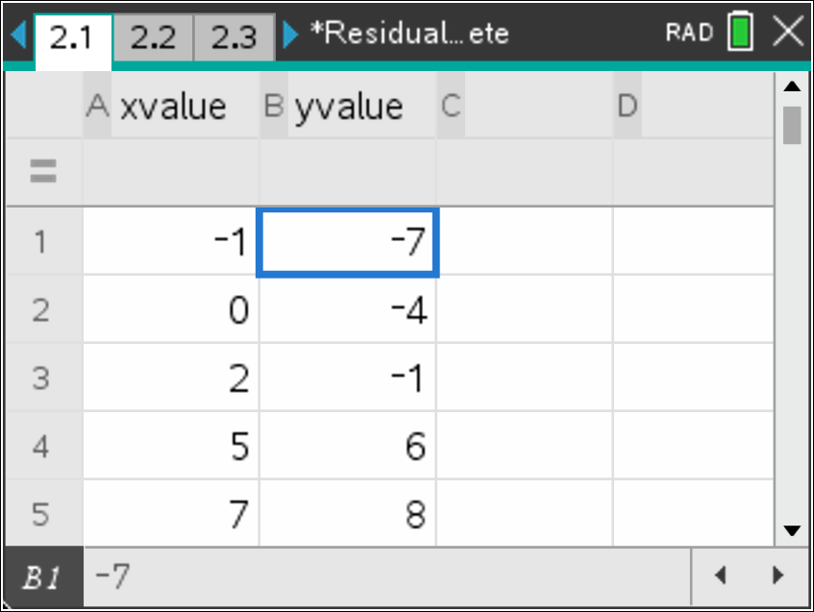
Tech Tip: Students must press enter or the down arrow after the last value is entered.
Add a page by pressing /~. Select>Add Calculator. Press b . Select> Statistics> Stat Calculations, then Linear Regression (mx + b). For X List: select xvalue and for Y List: select yvalue. Press enter for OK..  What is your linear regression equation?  Answer: The linear regression equation is | 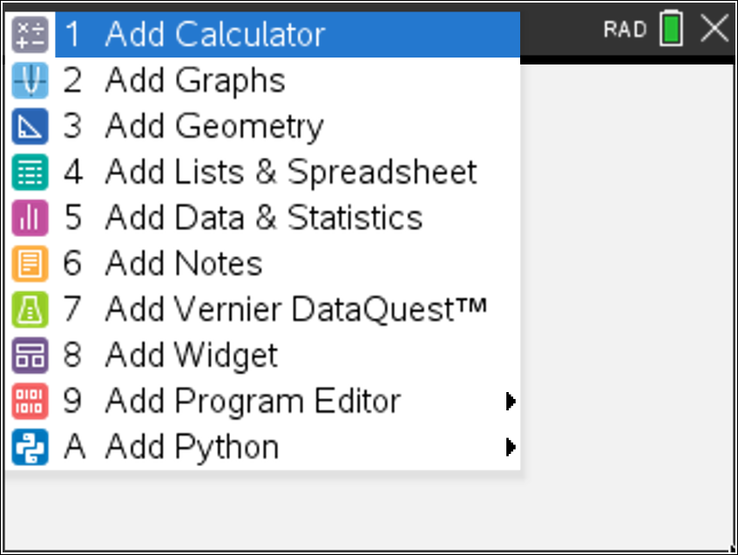  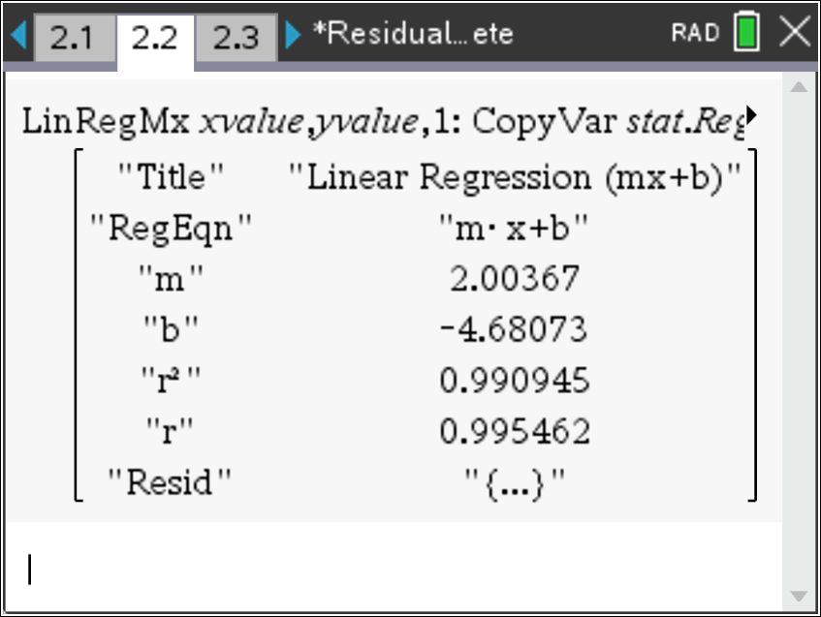
- Add a page by pressing /~. Select> Add Data & Statistics. Click in the lower gray region to select xvalue and click in the left gray region to select yvalue.  Note: To show the graph of the linear regression equation, press b. Select > Analyze> Regression, and Show Linear (mx + b). To hide the graph of the linear regression equation, press b. Select >Analyze>Regression, and Hide Linear (mx + b). | 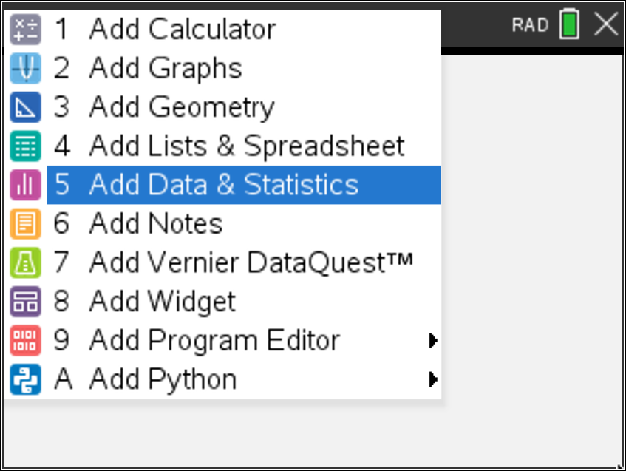
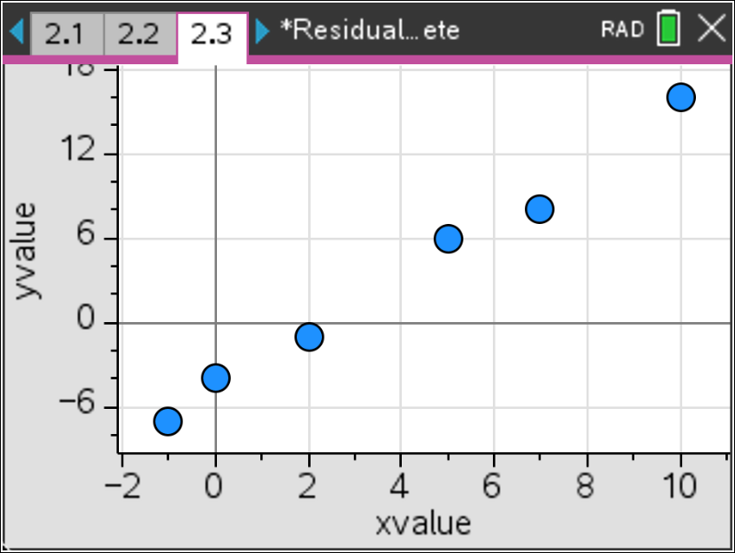
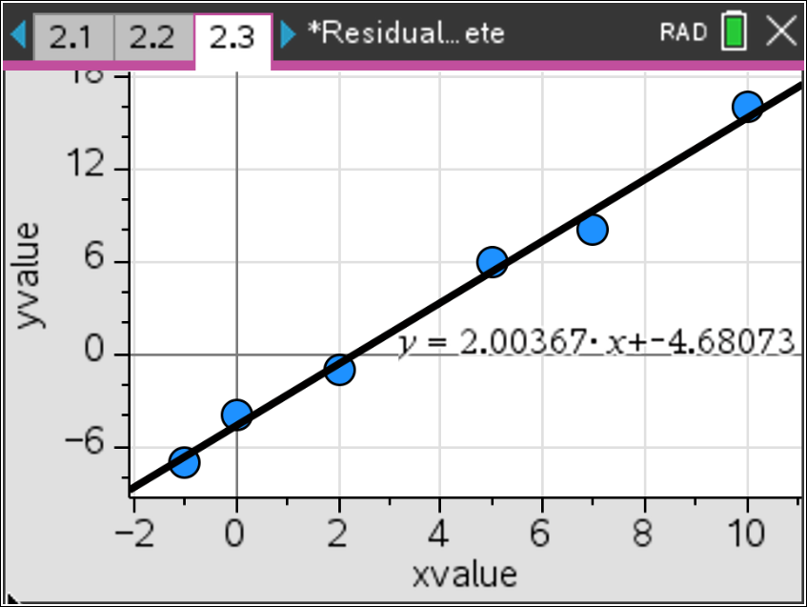
The residual is the actual value minus the predicated value. A regression model is justified as appropriate for a data set if the residuals of a regression, the residual plot, appear without pattern. To view the residual plot, click in the left gray region and select stat.resid.  Does your residual plot have a pattern? Would a linear regression be appropriate for this data set?  Answer: The residual plot does not have a pattern. A linear regression is appropriate for this data set. | 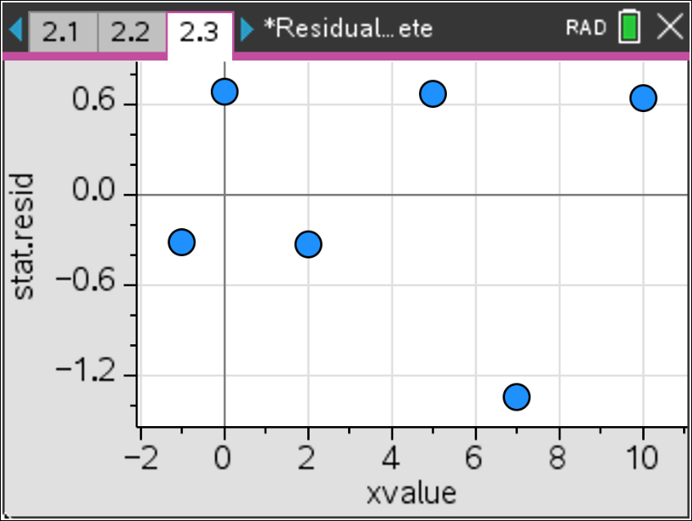
3. Add a page by pressing /~. Select> Add Calculator. To evaluate the predicted values, type f1(–1) and then calculate the residual when x is –1. Calculate f1(0) and then calculate the residual when x is 0. Notice that one residual value is negative and one is positive. What does this tell us about the predicted value as being an underestimate or an overestimate?  Answer:  f1(–1) = –6.68440367; Residual = –0.31559633  f1(0) = –4.680733945; Residual = 0.680733945  If the residual is positive, the predicted value is an underestimate. If the residual is negative, the predicted value is an overestimate.  Note: To view the residual list for all of the data points, press h and select stat.Resid. Scroll to the right to see more values. | 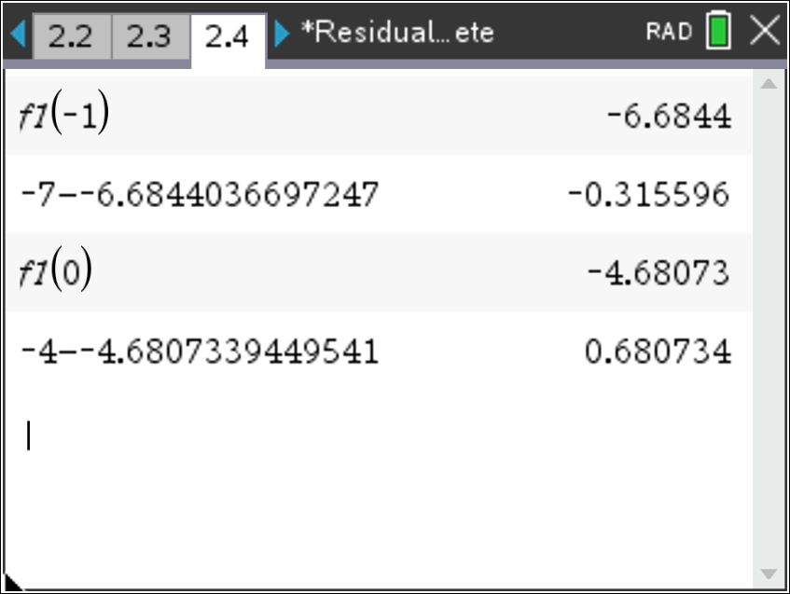  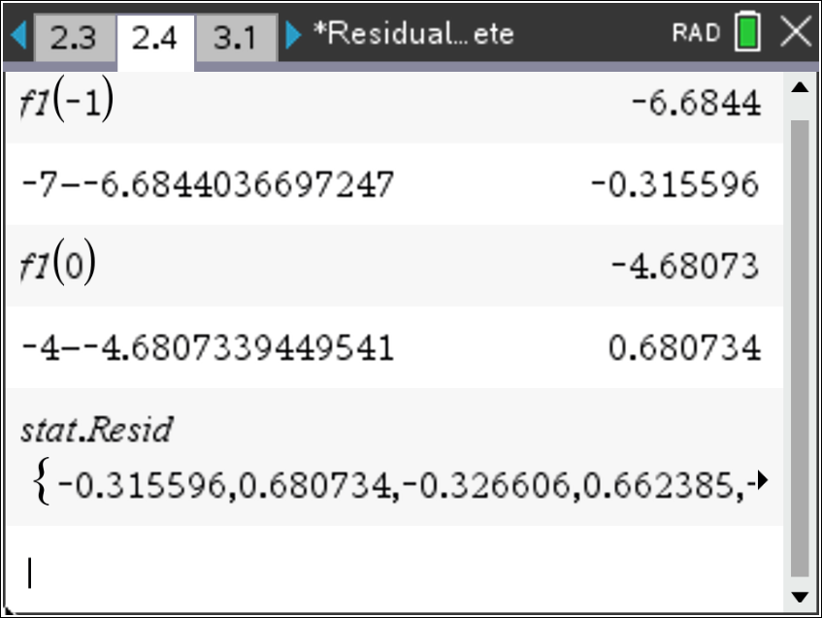
Teacher Note: The graph of the scatter plot with the regression equation may be helpful to visualize the overestimate or underestimate.
Move to page 3.1.

Part 2

Use the following data set in Part 2.

$$x$$ | –1 | 0 | 1 | 2 | 4 | 5
$$y$$ | 0.2 | 0.6 | 0.9 | 2.1 | 7.9 | 16.2

4. Follow the steps in Part 1. Enter the x values in the column labeled xvalue. Enter the y values in the column labeled yvalue. Compute a linear regression, view the scatter plot, and view the residual plot. Does your residual plot have a pattern? Would a linear regression be appropriate for this data set?  Answer: The residual plot appears to have a pattern. A linear regression is not appropriate for this data set. | 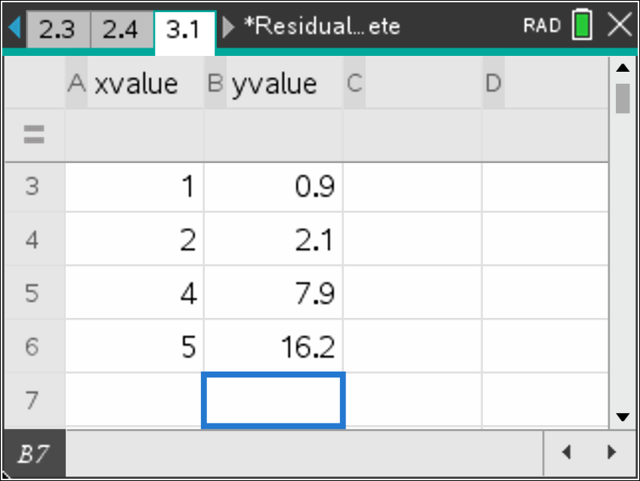  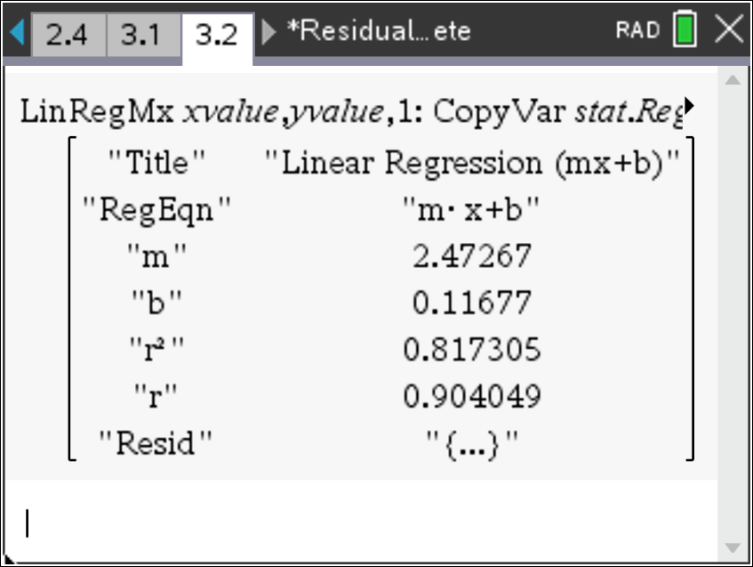  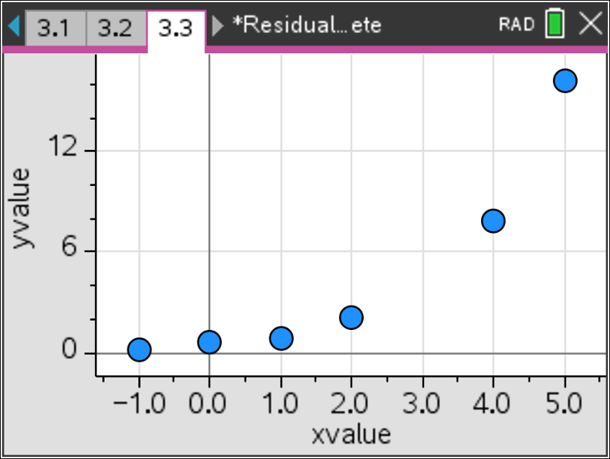  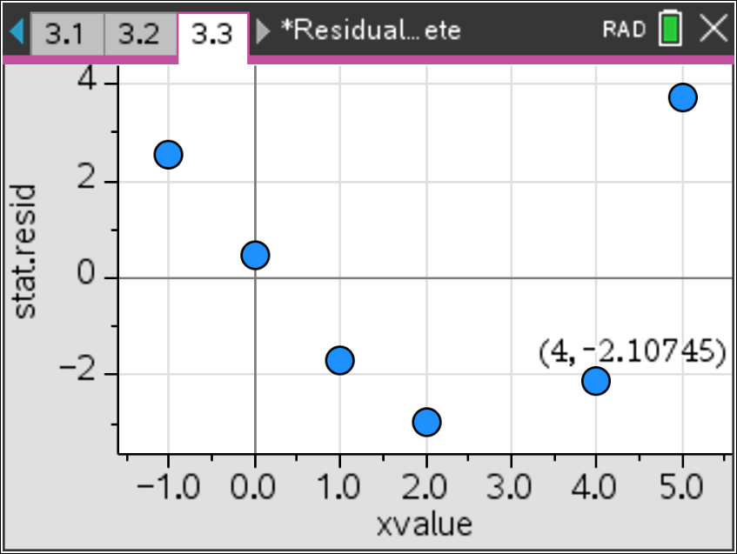
5. Now compute an exponential regression. Add a page by pressing /~. Select > Add Calculator. Press b . > Statistics, >Stat Calculations, then \ Exponential Regression. View the residual plot. Does your residual plot have a pattern? Would an exponential regression be appropriate for this data set?  Answer: The residual plot does not appear to have a pattern. An exponential regression is appropriate for this data set. | 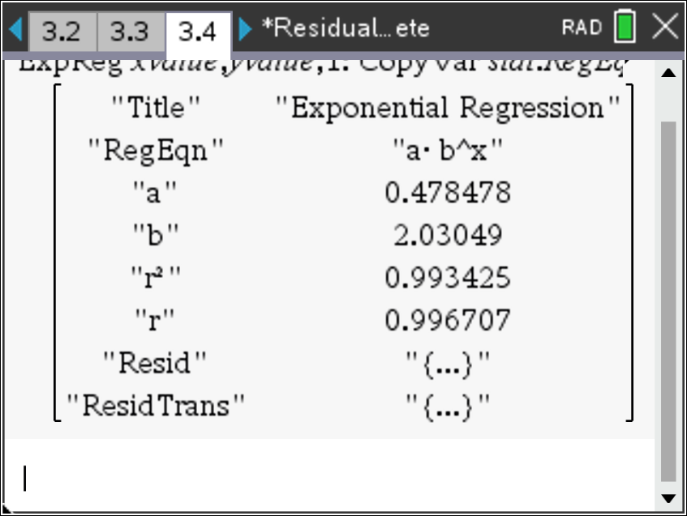  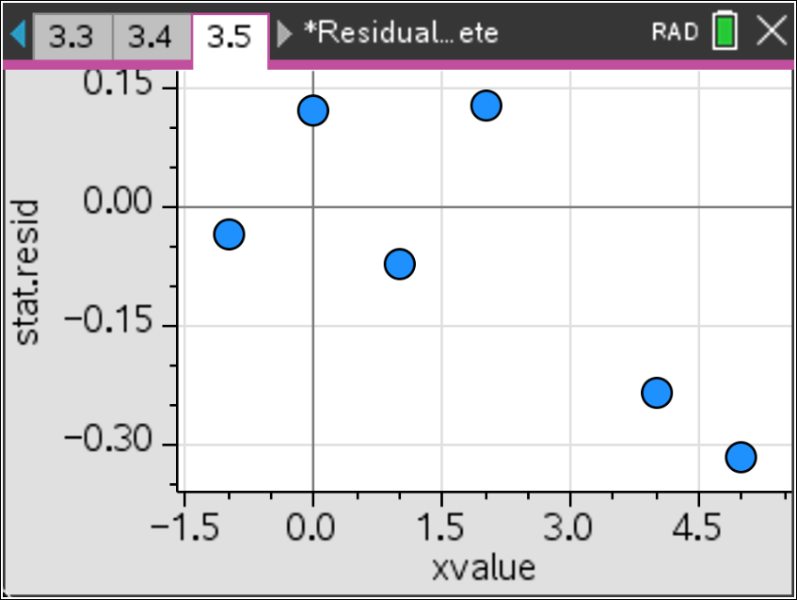

Extensions
- Find a data set that models a quadratic and ask the students to follow the steps for a quadratic regression. Observe the scatter plot and the residual plot.

Wrap Up
Upon completion of the lesson, the teacher should ensure that students are able to understand:
- How to input data and view scatter plots.
- How to compute linear, quadratic, and exponential regressions.
- How to plot residuals and determine if the residual plot has a pattern.

